A History of the Kronenberg Family

Compiled and written by Reinhard Marx
on the occasion of the installation of Stolpersteine in Geseke, June 18, 2022

Translation by Kenneth Kronenberg

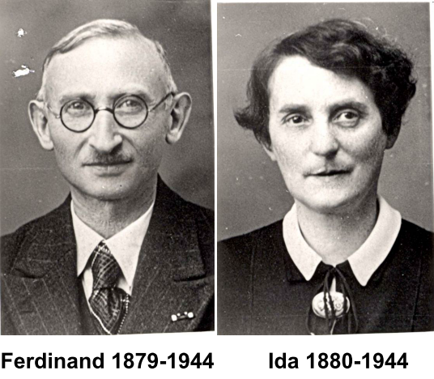

Contents:

1. Settlement in Geseke – The Family Progenitor Salomon Nachmann
2. The Störmede Family Line
2.1 Meyer Kronenberg
2.2 Dr. Aron Kronenberg, physician
2.3 Dr. Emil Kronenberg, physician
2.4 Berta Nussbaum, née Kronenberg
2.5 Nachmann Kronenberg, teacher
2.6 Salomon Kronenberg, teacher
2.7 Moritz Kronenberg, philosopher
2.8 Leopold Kronenberg, banker
2.9 Dr. Max Kronenberg, professor
3. The Geseke Family Line
3.1 Beginnings in the Itinerant and Rag Trades
3.2 History of Members of the Salomon Kronenberg Family
3.3 Nachmann Kronenberg and the Store on the Hellweg
3.4 The Jewish Cemetery in Geseke
3.5 Hedwig Kronenberg
3.6 Rosa Schönfeld, née Kronenberg
3.7 Brief biographies of Ferdinand Jelinowski and Ida Kronenberg
3.8 From East Prussia to the Ruhr Region
3.9 The Jelinowski-Jelin Family
3.10 The First World War
3.11 From Gelsenkirchen to Geseke
3.12 Boycotts and Flight
3.13 “Reichskristallnacht” and “Protective Custody”
3.14 Denial of Emigration
3.15 Help from Geseke Residents
3.16 Deportations and Holocaust
4. Notes

1. Settlement in Geseke – The Family Progenitor Salomon Nachmann

The location of Geseke on the Hellweg, an important east-west trade route, favored the settlement of Jewish merchants. Agriculture and crafts had been forbidden to Jews for centuries, so the only niche open to them was trade. Most of the Jews lived in modest economic circumstances and made their livelihoods by peddling. Some, like the Kronenberg family, gradually transformed their trade in rags into a flourishing textile business. Others made their livings in the cattle and grain trades, among them the Stern, Abel, Cohn, and Schild families.

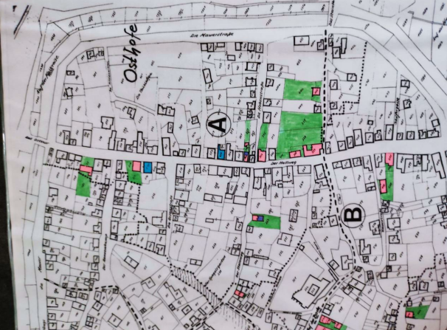

Jewish homes on the Hellweg in about 1820

While some families can be traced back for several generations in Geseke, the younger sons of other families often moved to the more economically promising towns in the Ruhr region, or to large cities such as Cologne, Frankfurt, Munich, or Berlin.

Although the Kronenberg family can be traced back quite far, the exact origins of any of the families cannot be precisely determined.

Family tree of Salomon Kronenberg

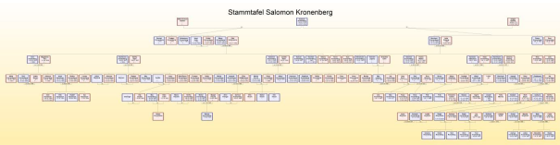

This comprehensive family tree is meant merely to provide an initial overview of the generations, which will be broken down into its component parts later.

The progenitor of the Kronenberg line in Geseke was Salomon Nachmann. According to Jewish tradition people did not have last or family names; rather, the second part of the name, Nachmann, would have been the name of his father, who in turn may have been called Nachmann Jakob, i.e., Nachmann, son of Jakob.

Naturally, this makes family research difficult because first names such as Salomon were quite common, and because a child generally received his grandfather’s first name, we find many descendants in a generation with the identical first name. When it became mandatory to have last names, Salomon chose the name Kronenberg.

In some cases, the choice of name presumably indicates the place of origin. For example, in the family tree below, the name Gütgen Spanier (Spaniard) could conceivably point to Sephardic origins on her side of the family. Kronenberg may also represent an as yet undetermined place of origin. In addition, names may have also had various spellings, such as Kronenberg/Cronenberg.

Family tree of Salomon Kronenberg

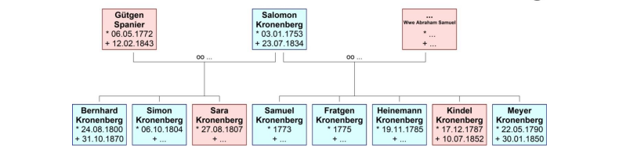

In 1825, when Salomon would have been in his 50s, the city of Geseke had 2837 inhabitants, of whom 148 were Jews, or 5.2% of the population. By comparison, the percentage for Prussia as a whole was between 0.5% and 1%.

Salomon’s first marriage was to the widow of Abraham Samuel, who brought her children Samuel and Fratgen into the marriage. That wife, whose name is unknown, bore children in that marriage named Heinemann, Kindel, and Meyer.

2. The Störmede Family Line
2.1 Progenitor Meyer Kronenberg

Salomon’s daughter Kindel married Isaac Halle from Störmede. After his premature death at the age of only 38, his widow transferred the “right of escort” [Geleit] to her brother Meyer Kronenberg.

The right of escort was a letter of safe conduct issued and sold by the prince that each Jew had to submit before being permitted to settle. The number of letters of safe conduct for a particular city was to be constant in number in order to prevent the excessive settlement of Jews. As a result, letters of safe conduct were highly prized and could be part of a dowry. Salomon’s marriage to Abraham Samuel’s widow may have been made possible by the acquisition of such a letter.

Family tree of Meyer Kronenberg
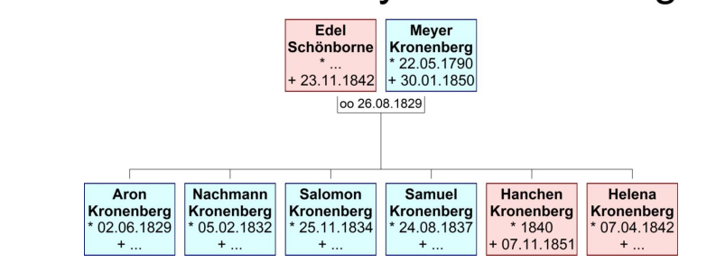

Thus, Meyer Kronenberg founded the Störmede line of the Kronenberg family. Störmede was incorporated into Geseke in 1975.

2.2 Aron Kronenberg, physician

Meyer’s son Aron was initially a teacher trained at the Haindorf Seminar, and worked in Oldendorf, Prussia, in 1847-1848. He eventually became a physician in the Bergisches Land.

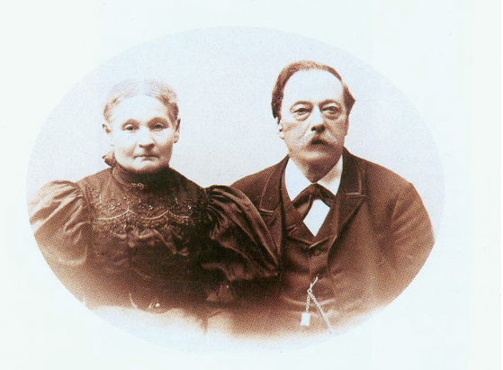

Dr. Aron Kronenberg and Amalie, née Treu

2.3 Dr. Emil Kronenberg, physician

Aron‘s son also became a physician, and was writer, Freemason, and politician, one of the founders of the hospital in Solingen, and of the Volkshochschule [adult education] and the city library. He was deported to Theresienstadt in October 1944, and after his liberation in 1945 returned to Solingen, where he died in 1954. There is a memorial plaque to him at the Volkshochschule-library building, as well as Stolpersteine for him and his wife Adele in front of their residence.

The following brief biography describes his career:

Max Leven Center, Solingen
Education and Memorialization

Dr. Emil Kronenberg was a respected physician in Solingen who was raised in the spirit of liberal humanism. Born in Leichlingen in 1864, he became a practicing physician in Höhscheid, in 1890, after his professional studies. He became an ENT physician in Solingen, in 1894. Judaism did not play any significant role in his family. In 1896 he married Adele Becker, who came from a Protestant business family. Forty-five years later his “mixed marriage” saved him from deportation.

Kronenberg published many articles based on his medical experience; he joined physician organizations and for many years served as their chairman. Together with three colleagues he founded the Bethesda specialty hospital located in the Friedrichstrasse. In World War I he served as Oberstabsarzt on the Western Front. He described the beginning of the war in his diary.

Social involvement was very important to him and his wife. Although Emil Kronenberg was never a candidate for political office, at the beginning of the Weimar Period he worked for the German Democratic Party (DDP) in city agencies concerned with health and education.

In 1933 he was forced to give up all of his honorary posts. His eligibility for reimbursement from health insurance plans was restricted, and in 1938 he was stripped of his medical license. Added to this professional exclusion were the numerous instances of personal humiliation, especially the Star of David that was mandatory after 1941. In July 1942, when the rest of the Jews who were not living in “mixed marriage” were deported, he assumed leadership of the Solingen office of the Reich Association of Jews in Germany.

Adele Kronenberg died on October 22, 1943, of a heart attack, on her way to an air raid shelter. Emil Kronenberg was arrested in September 1944 while visiting his wife’s grave. Together with other Jews from Solingen he was deported to Theresienstadt by way of Berlin. In his 80s, he was liberated in 1945 and returned to Solingen, where he fought for restitution.

“I consider it disastrous when hatred and vengeance play any considerable role because they can never lead to mutual understanding.”
Dr. Emil Kronenberg, September 1950

Upon his return, Emil Kronenberg joined the newly founded Free Democratic Party (FDP) and once again involved himself in the city’s education committee. He was passionate about literature. On September 1, 1949, he was a guest of honor at the 50th anniversary celebration of the Bethesda hospital that he had cofounded. He died on March 31, 1954 and was buried with his wife Adele in the cemetery in the Kasinostrasse.

The building with the city library and school, which resulted from the Kronenbergs’ involvement with the Solingen reading circle, bears his name. Stolpersteine were installed at their last address in the Kattenberger Strasse in January 2019.,

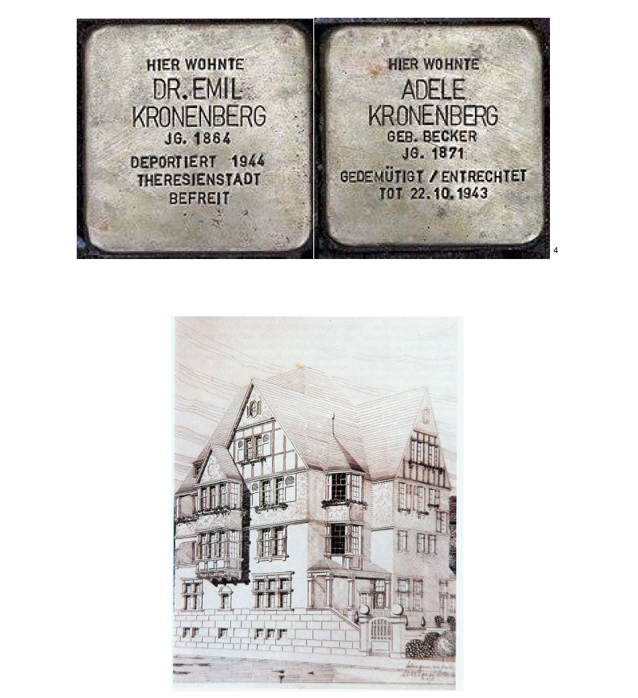

Residence in the Kattenberger Strasse

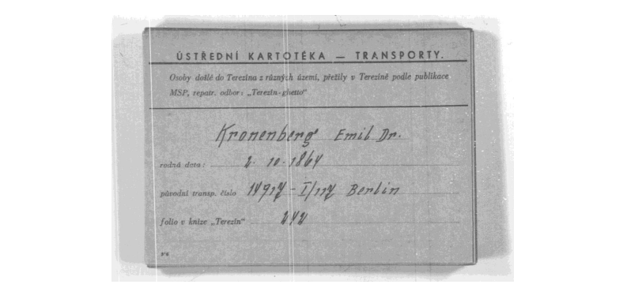
Transport card to Theresienstadt

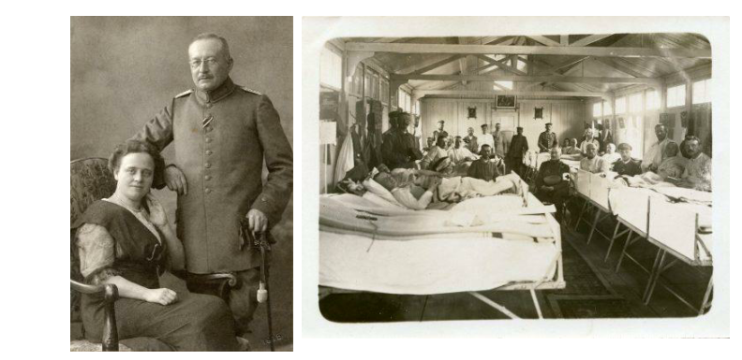

Left: Adele and Dr. Emil Kronenberg; source: Solingen City Archive, Na 25-21. Right: Dr. Emil Kronenberg (sitting in the center aisle with the Red Cross armband) in the field hospital during World War I; source: Solingen City Archive, Na 25-20.

Description by Dr. Emil Kronenberg (1864-1954), son of Aron Kronenberg, physician, born 1829 in Störmede:

At the age of almost 80, Dr. Emil Kronenberg was arrested on September 17, 1944 and taken to the Theresienstadt concentration camp. He returned to Solingen on July 1, 1945. In his memoirs, Dr. Kronenberg listed the anti-Semitic actions to which he had been subjected:

“April 1, 1933: Loss of civil rights. Guards were posted at our doors to prevent people from seeing Jewish physicians. Hindenburg’s order that Jewish war veterans should not be hindered in their work was never honored.

“April 2, 1933: The Jewish physicians in Solingen were excluded from compensation from health insurance plans. This caused considerable economic damage.

“1934: We were forbidden to treat patients covered by private and public health insurance plans. This increased the pressure on private patients. We were also forbidden to publish in the press or in scientific journals.

“1935: The Nuremberg Race Laws. We were forbidden to employ female personnel below the age of 45. I was banned from practicing at the Bethesda hospital. Public libraries of all sorts were forbidden, as was attendance of movies, concerts, and theater performances.

“1936: I was unable to find a successor to my medical practice. I was forced to sell my house at far below its market value. I receive a pension of 120 marks. By contrast, my insurance status should have provided me 3000 marks per month.

“1938: On October 1 all of my assets were blocked and placed under forced administration. I was stripped of my medical appointment. Individual Jewish physicians are permitted to treat only Jews. They may not represent themselves as physicians, but as ‘healers of the sick.’

“My apartment was ransacked. Approximately 5000 marks worth of furniture, cutlery, porcelain, and artworks were smashed.

“I was arrested on November 10 and taken to jail. I was released again the following afternoon. My driver’s license was revoked the same year. 25% of my assets were confiscated.

“1939: I was forced to relinquish anything of value. Received not even 10% of value in compensation. We are to be housed in a barracks.

“This outcome was prevented by an intercession. However, our living space is considerably diminished. My radio was confiscated.

“1940: The party confiscates my telephone in October.

“1941: I am banned from using the streetcars and trains. On September 17 we are ordered to wear the “Jewish star.”

“1943: My seriously ill wife dies in an air raid shelter. The district party group leader [Ortsgruppenleiter] harasses me repeatedly.

“1944: I am confined to a hospital with pneumonia from January to March. On September 17 I am ordered to report to the Gestapo with 10 kg of baggage and foodstuffs. The train travels to Ronsdorf by way of Wuppertal. Overnight in the cattle hall of a slaughterhouse. Arrival in Berlin after a 37-hour train trip.

“On October 13, travel to Theresienstadt, intestinal illness; tormented by lice and fleas. Typhus is rampant; gassing facilities are built, but luckily are not used. Soviet soldiers march into the camp in early May. Not only does the food get better, but I am able to return home on June 28.”

2.4 Berta Nussbaum, née Kronenberg

Aron’s daughter Berta married the teacher and cantor Israel Nussbaum. They, along with their daughter Annie, were deported from their home in Viersen to Theresienstadt and Auschwitz.

A detailed biography follows:

Berta Nussbaum, née Kronenberg
Berta Kronenberg was born on September 24, 1868, in Leichlingen, the daughter of the physician Aron and Amalie Kronenberg. She became a teacher at the lyceum, and then a housewife. On September 8, 1897 she married the teacher and cantor Israel Nussbaum (*March 24, 1869) in Elberfeld, whom she had met at a conference. They had four children: Annie (February 4, 1899); Ilse (March 11, 1904); Rudolf (September 9, 1902); and Otto (July 27, 1901). When each of the children turned three they were sent to the Protestant day school, which was only a few steps from their home. Their education under “Fräulein Stoßberg” was relatively tolerant. After 1897 they moved to Viersen, initially as renters, and then, after 1906, in their own home. The Nussbaums were good friends of the Jewish ENT specialist Dr. Abraham and his family.

When Israel was given a leave of absence and sent on a cure for neurasthenia and insomnia, she replaced him in the Jewish school for 3 months. In 1914 she became a member of the Viersen Fatherland Benevolent Society and in the same year founded the “war kitchen” at the Protestant school. For this she was awarded the Distinguished Service Cross. Beginning in 1915 she represented Jewish women in the leadership of the housewives association founded by Julie Kaiser. She was later made honorary chair. The housewives association played an important role in the social life of Viersen; its purpose was to promote professionalism in women through articles, lectures, exhibits, courses, and celebrations. Berta Nussbaum wrote poems for the celebrations and recited them. In her capacity as member of the association she traveled throughout Germany, including to Munich, Tübingen, Stuttgart, Pforzheim, Bremen, Hamburg, Magdeburg, and Nuremberg with an exhibit of “fashion dolls” that the Viersen association had organized. Other exhibit themes included “Once upon a time and now” and “The woman.” The housewives association organized events in Viersen as well. “The set table,” for example, represented a Passover table as it is set on the evening before Passover to commemorate the Exodus from Egypt. In 1933 she helped organize “The celebration of the elderly,” a Christmas celebration for people over 70, and even though she was 65 herself, she helped with the serving. However, in 1933 the Nazis forced her to give up all of her social involvements. In 1936 Berta and her husband visited their daughter Ilse in Palestine for five weeks. Despite being terribly abused during Kristallnacht, Berta, Israel, and daughter Annie decided to remain in Viersen. This decision sealed their fate. Berta was deported to Theresienstadt on July 24 or 25, 1942 from Aachen-Düsseldorf on transport VII/2, Train Da 71 (No. 781), where she died on April 17, 1943. Her name is listed in the Theresienstadt prisoners list.

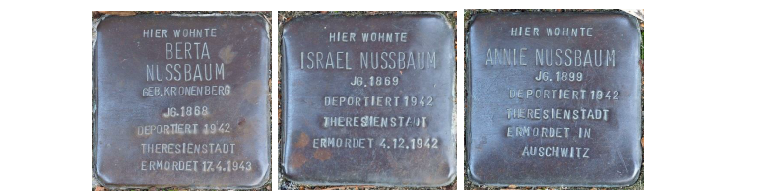
Nussbaum family Stolpersteine in Viersen

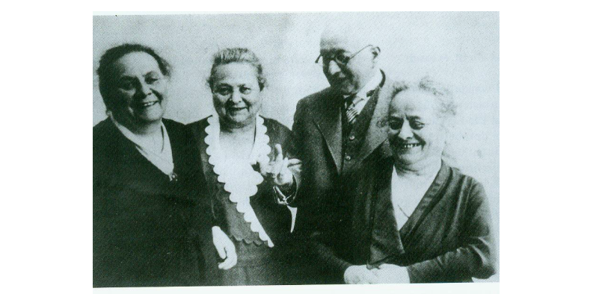
Emil with his sisters Berta, Adele, and Johanna

2.5 Nachmann Kronenberg, teacher

Aron’s brother Nachmann was born in Störmede in 1832; in 1865 he married Bertha Kahn, born 1837, the daughter of Abraham Gottschalk Kahn and his wife Marianne, née David. They had five children (Louise 1866, Max 1868, Johanna 1870, Regina 1873, and Laura 1875).

Nachmann worked as a teacher in Bünde from 1863 to 1890. Over time the community raised his salary from 900 marks to 1500 marks. In 1888 Kronenberg celebrated his 25th anniversary as a teacher. Among the officials who congratulated him was the Catholic priest who functioned as the local inspector of schools, along with the senior clerk of Bünde, and the entire city council. In addition, he served as a cantor for more than 40 years. Nachmann died in 1924 and was buried in the cemetery in Enger. His daughter Regina, married name Strasser, died in 1920. His daughter Laura, married name Sander, was deported to Theresienstadt in 1942, and from there to Auschwitz on May 15, 1944.

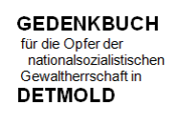

Sander, Laura, née Kronenberg
born April April 20, 1875 in Bünde

Religion: Jewish

Occupation: Store owner

Daughter: Elly Sickinger, née Sander, born August 16, 1906)

Residences: October 10, 1931 Paulinerstr. 15
August 18, 1933 Bertastrasse 16 bei Sickinger
now Gudrunstr. 25
April 28, 1942 Gartenstr. 6 bei Arensberg
July 28, 1942 “Reported departure to Theresienstadt”

The residence card of the city of Detmold notes that “Both grandparents are full Jews.”

After attending school, Laura Sander passed a business apprenticeship and worked as a saleswoman, cashier, and travel representative. She moved to Detmold in 1907. Until 1913 she was the head of a branch store that sold corsets, which she later owned. Until 1929 her store was located at Langen Strasse 26, and until the end of 1933 at Bruchstrasse 30. She was forced to close the store in June 1933 because the Nazis’ anti-Semitic actions.

In 1942 she was ordered to the so-called Jew house at Gartenstrasse 6. From there she was deported by way of Bielefeld to Theresienstadt on July 28, 1942 on Transport No. 485-XI/1. She was deported to Auschwitz on May 15, 1944 on Transport Dz.

She was declared dead, and the date of her murder was officially set at December 31, 1945.

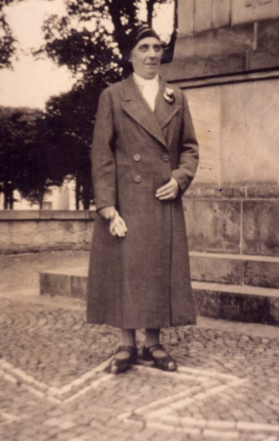
Laura Sander, undated (StdA DT DT V 19 No. 176)

Nachmann’s daughter Johanna, the widow of Julius Mosberg, was deported to Theresienstadt in 1942, where she was murdered on March 3, 1944.

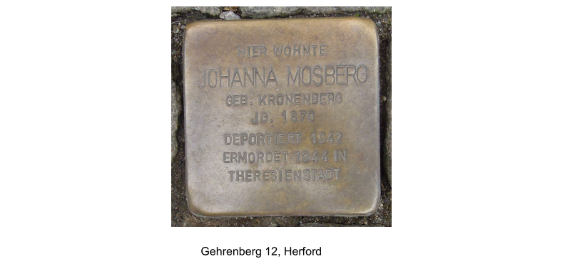

2.6 Salomon Kronenberg, teacher

Aron’s other brother Salomon, born in 1834, in Störmede, married Jeanette Wahl in 1861, in Vlotho. She was originally from Niederalme.

Family tree of Salomon Kronenberg

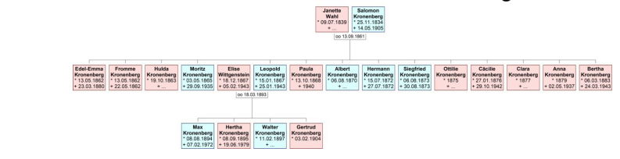

Salomon was a teacher by profession; he taught in Vlotho from 1860 to 1866. That was also where his first four children were born.

He was hired to teach in Geseke in 1867, where his next five children were born, of whom two died shortly after their birth.

In 1874 he was hired to teach in Duisburg/Ruhrort. In the following years, his family expanded by another five children, so that in all Salomon had 14 descendants.

He died in 1905, in Nieder Wildungen, which today is called Bad Wildungen.

2.7 Moritz Kronenberg, philosopher

Salomon’s son Moritz made his name as an author and held a doctorate in philosophy. He wrote copiously about Kant and other representatives of German Idealism. He died in 1935 after being stripped of his license to lecture and teach at the university.

The following is a brief biography from Bücher.de, and a select bibliography. In addition to his numerous books, Moritz Kronenberg wrote hundreds of articles on philosophical and political subjects in Ethische Kultur, Die Naturwissenschaften, and other periodicals:

Moritz Kronenberg, author and philosopher

Born: April 3, 1865 in Vlotho, son of the teacher Salomon Kronenberg, born 1834 in Störmede
Died: September 21, 1935 in Berlin-Charlottenburg

Moritz Kronenberg was a German philosopher and author, publisher and editor of the weekly journal Ethische Kultur [Ethical Culture]. In German philosophy, the era from Immanuel Kant to Georg Wilhelm Friedrich Hegel and the late works of Friedrich Wilhelm Joseph Schelling are known as German Idealism. The dates extend roughly from the publication of Kant’s Critique of Pure Reason in 1781, to the death of Hegel in 1831. The period of German Idealism is widely considered the golden age of German philosophy. Kronenberg’s Geschichte des Deutschen Idealismus [History of German Idealism] in two volumes examines two periods of German Idealism. In the first volume he looked at idealism from its beginnings to Kant; in the second, from Kant to Hegel. The book is an excellent example of how the street of philosophy can aid in the project of intellectual renewal. Today both this work and its author have unjustly fallen into oblivion. According to Kronenberg, the book “is thus about a history of ideas, cultural trends, and historical conceptual connections, not a history of the personalities who advanced these ideas…. Accordingly, the history of German Idealism would only be treated pragmatically consistent with a pragmatism of the spirit, whose nature will, I hope, emerge more clearly over the course of the book.”

Select bibliography
Moderne Philosophen. Porträts und Charakteristiken [Modern philosophers: Portraits and Characteristics] (1899)
Geschichte des deutschen Idealismus [History of German Idealism] (vol 1, 1909; vol. 2, 1912)
Kant. Sein Leben und seine Lehre [Kant: His Life and Doctrines] (1897, 1905)
Friedrich Nietzsche und seine Herrenmoral [Friedrich Nietzsche and His Master Morality] (1901)
Ethische Präludien [Ethical Preludes] (1905)
Gewalt und Gedanke. Eine Untersuchung über deutsche Kriegsschuld und Sühne [Force and Thought. An Examination of German War Guilt and Atonement] (1920)
Der politische Gedanke [The Political Idea] (1922)
Herder’s Philosophie nach ihrem Entwickelungsgang und Ihrer historischen Stellung [The Development of Herder’s Philosophy and Its Historical Position] (1923)

Moritz Kronenberg apparently also wrote under the pseudonym Philalethes Montanus.

2.8 Leopold Kronenberg, banker

From the explanatory text linked to the Stolpersteine of Leopold and Elise Kronenberg, Berlin:

Leopold Kronenberg was born on January 15, 1867 in Geseke, Westphalia, the son of the teacher Salomon and his wife Linchen. The family moved to Ruhrort in what is today part of Duisburg, where Salomon was hired by the Jewish school. At least three of Leopold’s siblings were born there.

Elise Wittgenstein, daughter of Hermann and Berta Wittgenstein, was born on December 18, 1867, and lived in Ruhrort. Hermann Wittgenstein was a respected representative of the local Jewish community and owned a successful lamp factory. Elise Wittgenstein had three brothers.

Leopold and Elise Kronenberg had been childhood friends, and they probably attended the same class at the Jewish school. They married on March 18, 1893, and soon moved to Berlin, where they had a total of four children. Leopold was a banker until the economic crisis of the early 1920s. It is not known what he did thereafter. In the end, the couple was supported financially by their sons Max, an engineer and later professor at the Technical University in Berlin, and Walter, also a banker.

The Kronenbergs were enlightened and assimilated Jews who celebrated both Jewish and Christian holidays, including Christmas. Throughout his life, Leopold considered himself a German patriot. Both of his sons had fought in World War I, during which Walter sustained serious injuries.

Only after the Nuremberg Race Laws were decreed in 1935 and Max was stripped of his license to teach did he and his family emigrate to the United States, in 1936. Leopold and his son Walter continued to believe that the terror unleashed by the Nazis would abate. Even Leopold’s arrest, in 1934, leading to his attempted suicide during his imprisonment, failed to convince them otherwise. Only after Kristallnacht in 1938 and Walter’s repeated arrests did the Kronenbergs begin to consider leaving Germany.

Although Max continued to work relentlessly from the United States on behalf of his parents’ emigration, and Leopold spent all his financial resources on the effort, in the end the necessary papers could not be procured. Changes in German emigration laws and the entry of the United States into the war made legal emigration impossible. Only Walter and his family were finally able to emigrate to the United States – after relinquishing all their assets.

In 1941 the Kronenbergs lost their residence at Innsbrucker Str. 14/15 and were forced to rent at various locations. Their last communication with their children in the United States was on July 28, 1942, in which they announced their impending deportation. They were taken to Theresienstadt on August 5 , 1942, where Leopold died on January 25, 1943, as a result of exposure to the cold and starvation. Elise met the same fate on February 9, 1943.

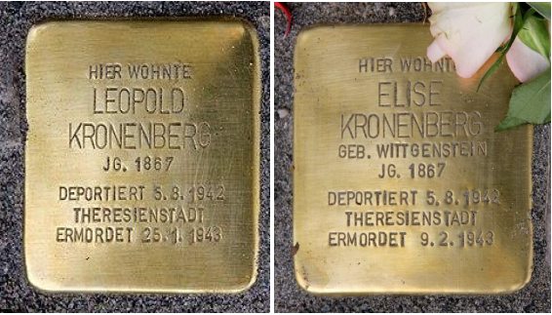
Stolpersteine for Leopold and Elise Kronenberg

Leopold’s sisters Cäcilie and Bertha were also deported, and murdered at Riga and Theresienstadt, respectively. A Stolperstein was installed in Berlin for Cäcilie as well.

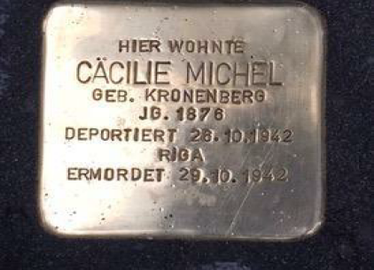
Stolperstein for Cäcilie Michel, née Kronenberg
Family tree of Leopold Kronenberg
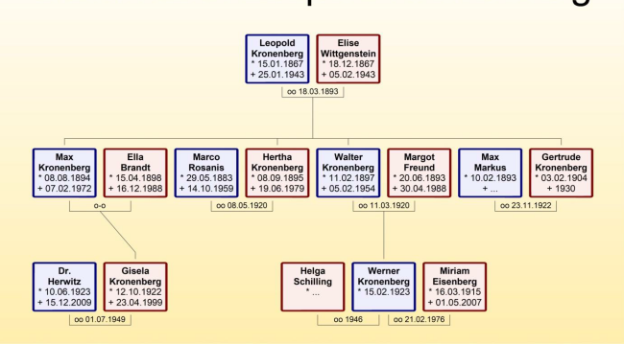

2.9 Prof. Dr. Max Kronenberg

Max Kronenberg, the son of Leopold Kronenberg, became internationally known for his work relating to the machining of metals and as a pioneer in production technology. He emigrated to the United States by way of England and settled in Cincinnati Ohio. His published works include Machining with Single Point Tools (1940), Trends in the Design of Metalworking Machinery and in Production Methods (1966), and Machining Science and Application: Theory and Practice for Operation and Development of Machining Processes (1966).

According to the page dedicated to the collection of his scientific papers at the Smithsonian Institution:

This collection includes technical reports containing laboratory notes, charts, graphs, drawings, and diagrams relating to Kronenberg's career as a researcher and analyst in the field of machining of metals from the 1920s to the 1960s. The papers are in English, in Kronenberg’s native German as well as in French, Russian and Spanish. They relate to his employment with the Cincinnati Milling Machine Co., as well as his later career as independent consultant, including his work on United Nations studies of the machine Industry in developing countries.

Max Kronenberg was born in Berlin, Germany in 1894 and was educated there. He served in the German Army in World War I. Returning to Berlin he completed his higher education earning a doctorate in Mechanical Engineering at the University of Berlin in 1927. He served as a professor there, but later moved to the U.S. where he was employed by the Cincinnati Milling Machine Co. in 1936. He specialized in developing techniques for machining of metals and became internationally known in the field, publishing more than 140 papers on those subjects in several languages. In 1941 he became a naturalized U.S. citizen and in 1945-1946 was consultant to the Secretary of War. Later he assisted the U.S. delegation to the U.N. and received numerous honors and awards from technical associations and societies. From 1948 he was self-employed as a consulting research engineer. He died in 1972 in Cincinnati.

Max Kronenberg’s professorship title in Germany was restored after the war.

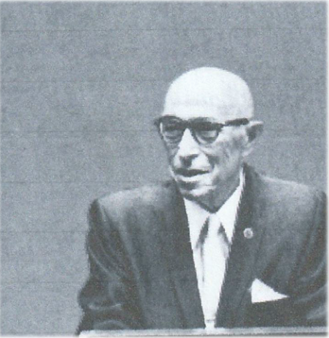
Max Kronenberg, undated

Max Kronenberg’s sister Hertha, who married Marco Rosanis, died in 1979, in Fort Wayne, Indiana. His sister Gertrude married Max Marcus; she died in 1930.

3. The Geseke Family Line

Here again is an overview of the Störmede family line:

Family tree of Salomon Kronenberg

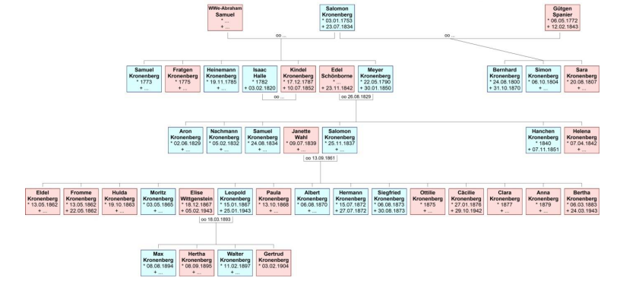

3.1 Beginnings in the itinerant and rag trades

Salomon initially lived in humble circumstances and made a precarious living in the itinerant trade in used goods, this being one of the few livelihoods open to Jews. However, this mode of employment frequently caused Jews to be subjected to harsh conditions imposed by the local authorities. Thus, for example, the magistrate in the city of Geseke denied an application for a letter of safe conduct to a Jew, supposedly to protect Christian residents from harmful trafficking.

“The supplicant is the second son of the local trade Jew Jacob Schiff, who has lived off of trafficking. He slinks from house to house and looks to see whether careless or thoughtless people might be living there to whom he can sell something that is perhaps not superfluous at half-price on the sly. Only in this manner can he have acquired his alleged assets, because he cannot have gotten such assets from his parents because they themselves possess nothing, nor have acquired something in their business because they pursue small trade such that they only pay 1 thaler [in taxes] annually….”

Eventually, Salomon resided at Bachstrasse 27 (Haus “Brockhoff, left; photos below by Franz Wilhelm Kersting)

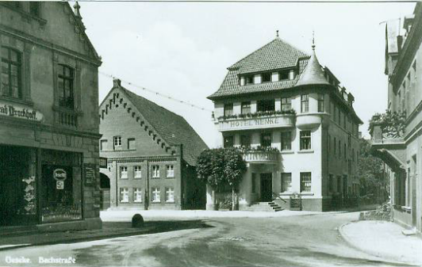

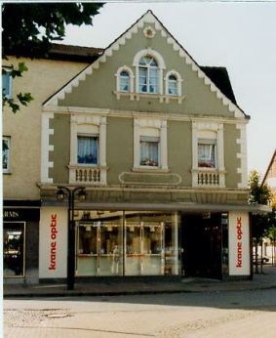

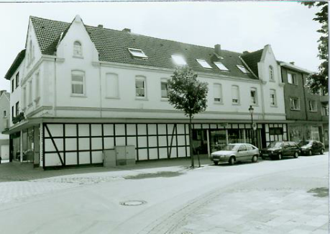
Salomon’s son Bernhard ran a successful business in the rag trade at this site. Bernhard married Jette Kleberg from Meinberg, and they had eight children.

Family tree of Bernhard Kronenberg

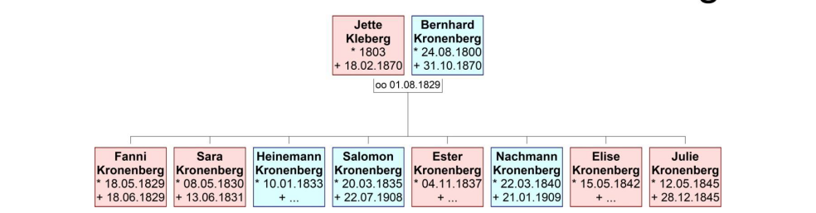

3.2 History of Members of the Salomon Kronenberg Family

Their son Salomon (1835-1908) married Hanna Mahler from Lichtenau and continued that trade in the Bachstrasse. Salomon and Hanna had three children, Ida, Emil Max, and Bruno Bernhard.

Ida married Max Laquer in 1897. They lived in Düsseldorf and Cologne. Max died in 1937 in Cologne; Ida emigrated to Bristol, England, where she died in 1950.

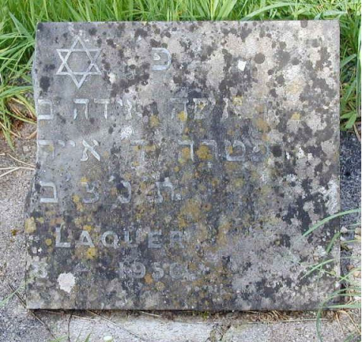
Gravestone of Ida Laquer
Her daughters Annamarie and Lucie died in 1990 and 1994, also in England. Her daughter Lina Margarete married Fritz Jochanan Erkan from Cologne, with whom she emigrated to Palestine, where she died, in Jerusalem, in 1991. They lived on a kibbutz and had a son and a daughter.

Salomon’s son Bruno Bernhard was married to Selma Goldberg. Their son Fritz was born in 1899.

Emil Max is listed as a factory director in 1900, residing at Marktplatz 8. His first marriage was to Sara Bach, daughter of the businessman Max Bach and Friederike Schmitt from Zeltingen on the Mosel. Their first daughter Lina was born in 1901.

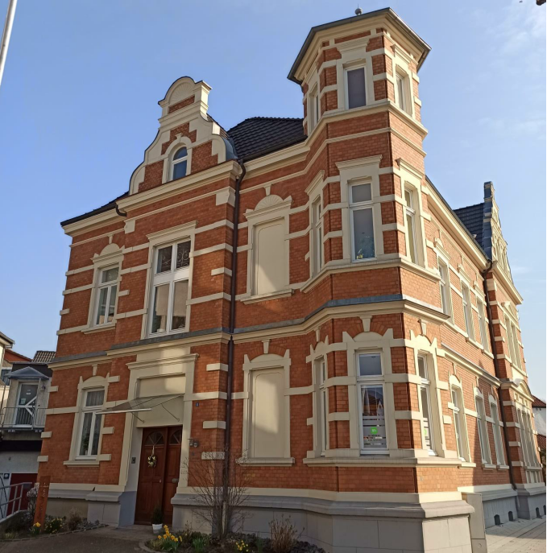
Marktplatz 8

Their daughter Paula Ruth was born in Bochum on October 12, 1914. The family appears at various addresses in Cologne in the 1920s. This was also where Emil and Sara divorced.

Hans Hesse described their further life in his “Kronenberg Journal”:

“Ruth Kronenberg attended a lyceum in Cologne until Easter 1932. After her education she wanted to become a tailor, and she was hired as an apprentice tailor. When the National Socialists came into power in 1933 she was forced to give up her position. She then found another position in a shop that was run by two Jews. In 1935, shortly after completing her training and passing her apprenticeship examination, she began to work independently for the Cultural Federation of German Jews, for which she produced costumes for the theater. She also had private Jewish customers. Initially she worked out of her mother’s apartment, and she hoped to open her own tailoring shop for women in the future.”

Because of the increasing repression in Germany, Ruth moved to Paris, where she tried to find work as a tailor. This was very difficult because she had a hard time adapting and didn’t have the financial means to take on larger projects. After the war broke out in 1939 it was no longer possible for her to practice her profession. In Paris she made the acquaintance of local artists and lived with the avant-garde poet and writer Roger Gilbert-Lecomte at Rue Bardinet 16.

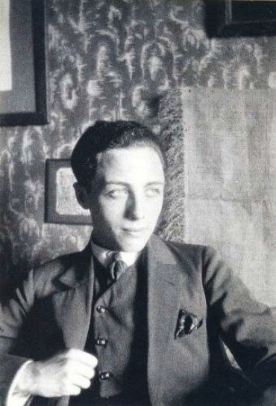
Roger Gilbert-Lecomte

In May 1940 Ruth was interned at the Gurs internment camp in southern France.

“The next wave of interments after the German Wehrmacht conquered the Netherlands, Belgium, Luxembourg, and France began in May 1940. At this time, the French government ordered the internment of all German women. Once the war began, all men living in France who came from Germany had already been interned. Many of the “foreign enemy women” who had fled the Nazis from Germany and Austria were brought to the Gurs camp. The signing of the armistice between Germany and France in June 1940 created a political vacuum that caused confusion in the camp administration. As a result, the camp was opened up, allowing many of its inmates to flee to the United States.”

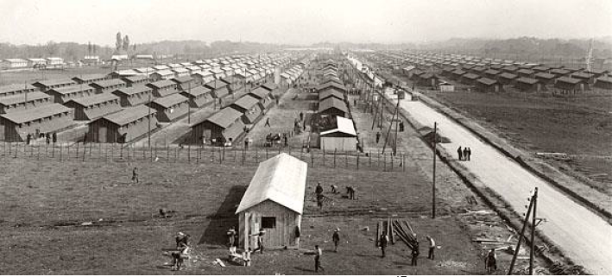
Gurs internment camp, about 1940

Ruth and her friend Gerda Groth fled and found refuge in Carcassonne. In a letter to Ruth’s mother Sara, Gerda described that in the summer of 1942 they had spent three weeks on the Mediterranean at Collioure, but they were stopped on their way back in Perpignan and arrested. Gerda was released after a few days, and she tried in vain to gain Ruth’s freedom as well. However, Ruth was deported from Drancy to Auschwitz on September 11, 1942. Her name is listed on the Shoah Memorial, in Paris.

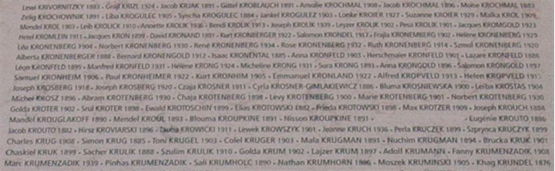
Ruth’s mother Sara fled to England in 1939 with her son Max Hermann, where in the 1950s she applied for restitution. In 1957 she wrote to the International Tracing Service in Arolsen, asking for information on the fate of her daughter Ruth.

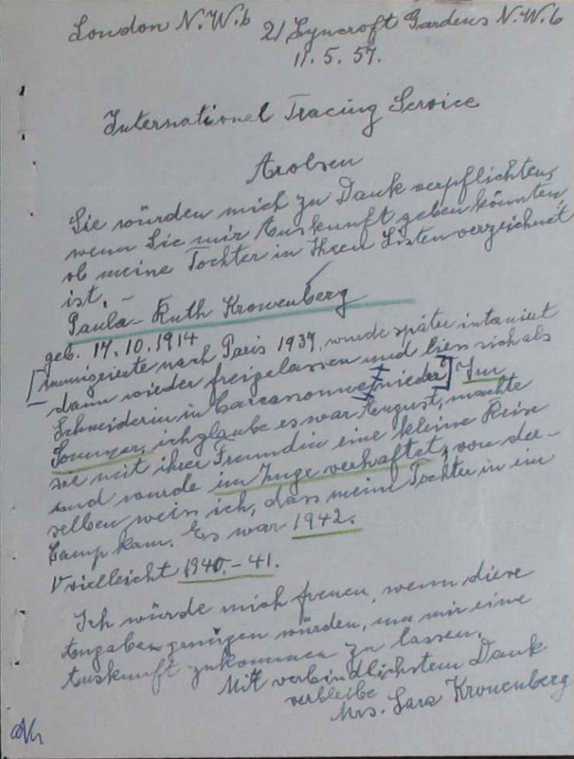

[Translation]
London N.W. 6
21 Lyncroft Gardens N.W. 6
May 11, 1957

International Tracing Service, Arolsen

I would be most grateful to you for any information you can give me about whether my daughter is on your list: Paula-Ruth Kronenberg, born October 17, 1914.
She immigrated to Paris in 1939 and was later interned and then released and settled in Carcassonne as a tailor. I believe that in the summer, in August, she went on a small trip with her friend and was arrested in the train. From [her friend] I know that my daughter was brought to a camp. That was 1942. Perhaps 1940-41.
I would be very happy if this information suffices for me to receive information.
Gratefully yours, Mrs. Sara Kronenberg
Ruth’s father Emil was next married in 1922 to Erna Heymann from Dortmund. They initially lived at Cimbernstr. 6, in Düsseldorf.

In 1937 the couple emigrated to San Remo in Italy, where they operated a pasta company (“pastificio”), which, however, failed in 1938.

Their German citizenship was revoked in 1939, and from 1940 until the liberation by the Allies in 1943 they were interned in southern Italy. In 1945 they returned to San Remo.

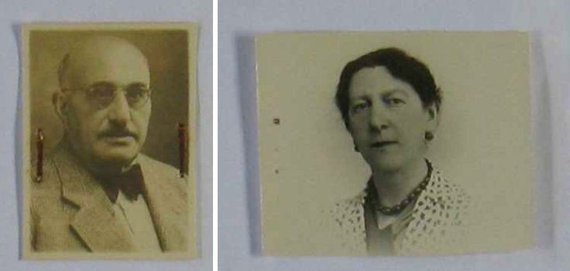
Emil Max Kronenberg and his wife Erna Heymann

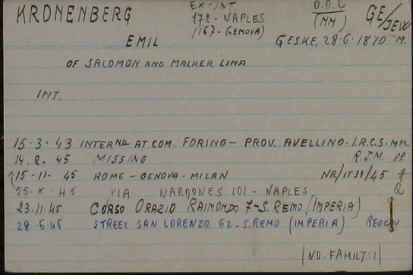

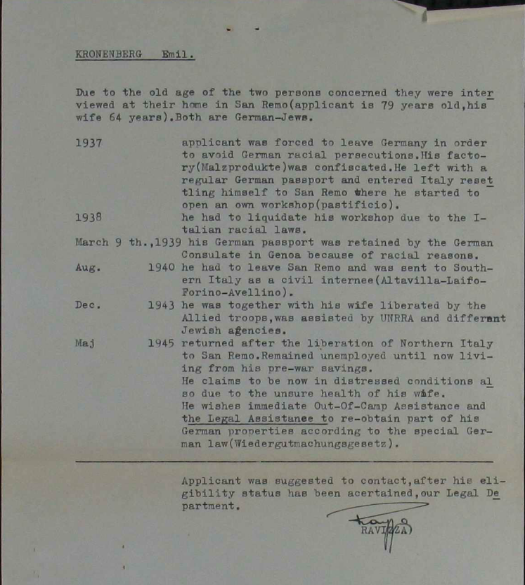

3.3 Nachmann Kronenberg and the Store on the Hellweg

Bernhard’s son Nachmann eventually opened a store at Hellweg 16; however, the exact founding date has not yet been determined. He married Johanna Dalberg from Essentho in January 1870. Their children were Hedwig, Albert, Bernhard, Rosa, and Ida.

Family tree of Nachmann Kronenberg
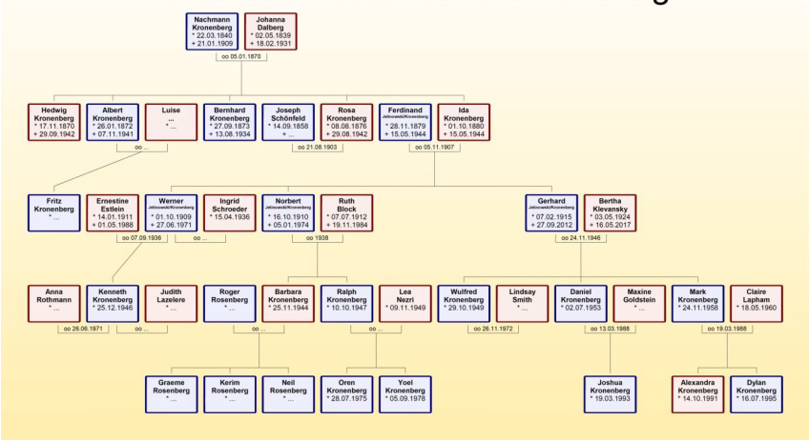

As described in his advertising, Nachmann ran a modern store that featured clothing and colonial wares. It thrived in Geseke.

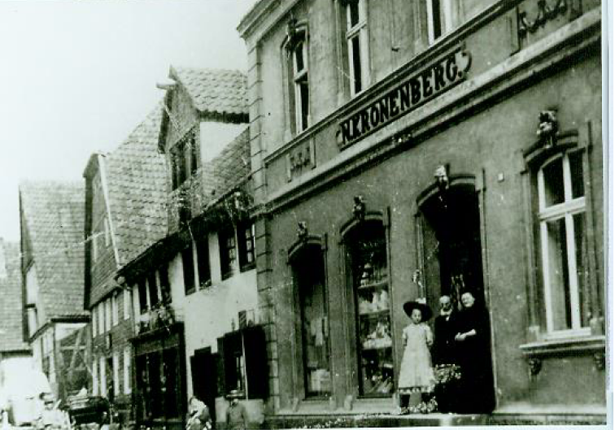
Photo taken in about 1900: Nachmann with his wife Johanna and daughter Ida

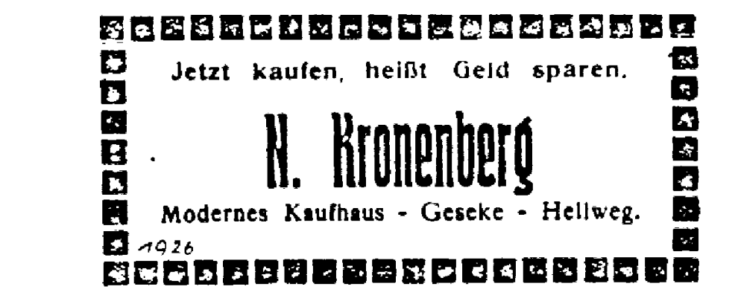

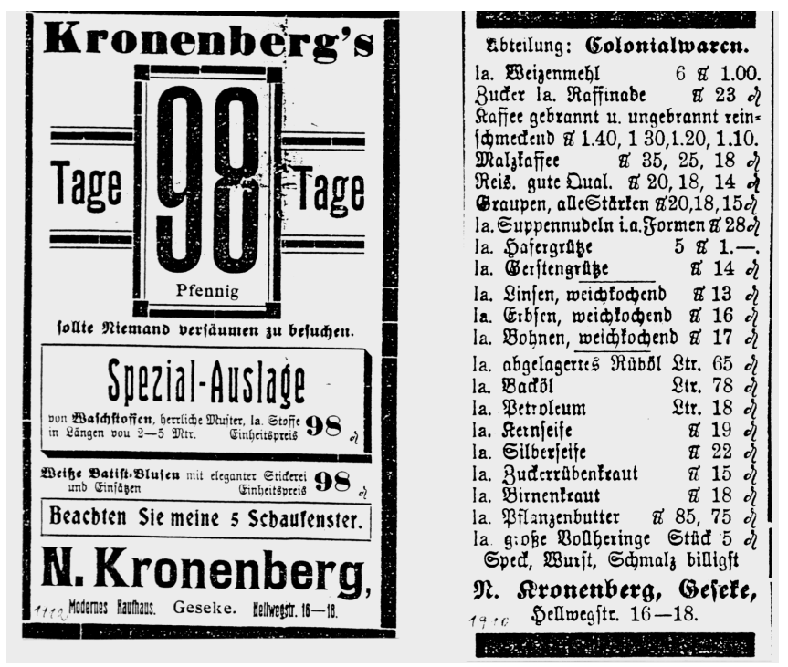

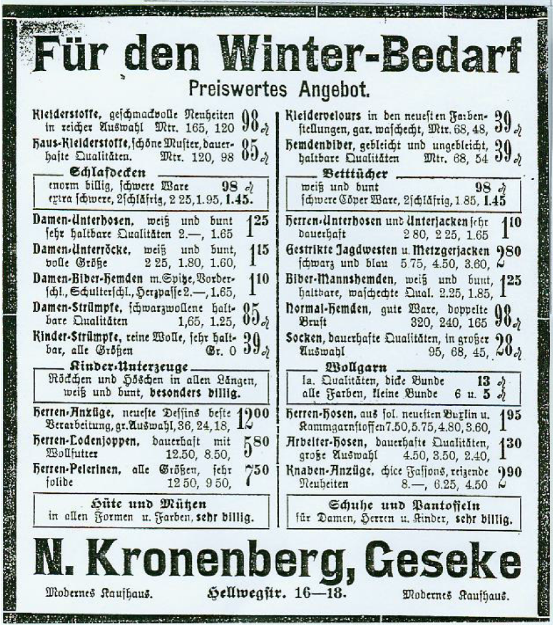

3.4 The Jewish Cemetery in Geseke
Nachmann died in 1909. His gravestone and that of his wife Johanna are located in the Jewish cemetery in the Ehringhauser Strasse, in Geseke. His parents Bernhard and Jette, his brother Salomon and his wife Hanna, along with Nachmann’s son Bernhard are also buried there.

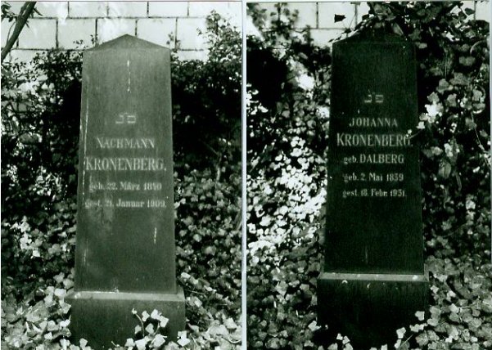
Gravestones of Nachmann (1840-1909) and Johanna Kronenberg (1839-1931)

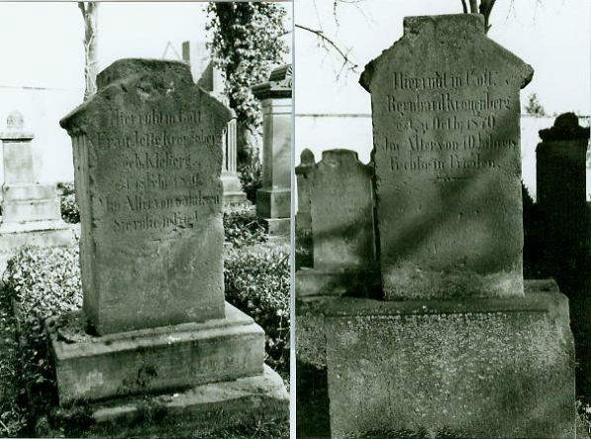
Jette Kronenberg (1803-1870) and Bernhard Kronenberg (1800-1870)

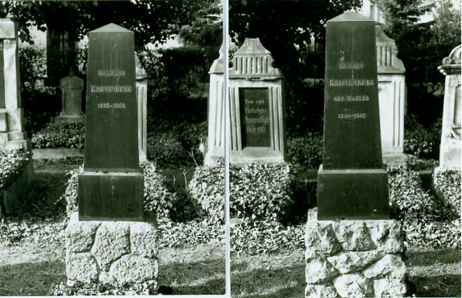
Salomon (1835-1908) and Hanna (1840-1887) Kronenberg

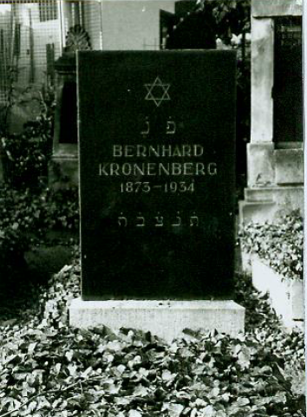
Bernhard Kronenberg (1873-1934)

In 1914, Johanna Kronenberg, Nachmann’s widow, signed an inheritance agreement with her son Bernhard, who had already taken over the running of the store. According to this agreement he would become the sole universal heir upon her death. The further distribution of money and household goods was laid out in detail:

“4. Daughter Ida, Frau Jelinowski, in Gelsenkirchen, has been fully compensated from her parents’ estate; she has counted everything that she has received against her inheritance and hereditary portion. Of her mother’s jewelry, she is to receive in addition a gold ring with diamond.
5. The grandchildren Werner and Norbert Jelinowski, in Gelsenkirchen, are each to receive 300 marks, payable six months after the death of their grandmother.”

The photo below show Johanna on the occasion of her 90th birthday. She died two years later.

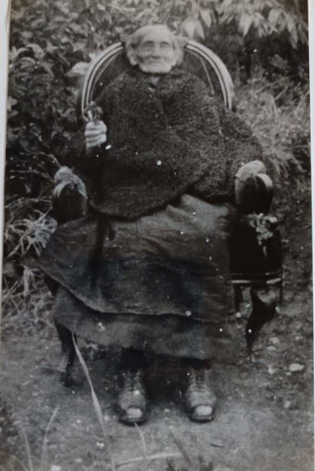

3.5 Hedwig Kronenberg
Neither Bernhard nor his sister ever married. Hedwig moved to Wiesbaden, from where she was deported to Theresienstadt on September 1, 1942, and then to Treblinka on September 29, 1942. The deportation record states:

Born November 17, 1870
Transport XII/2, nr. 762 (02. 09. 1942, Frankfurt am Main -> )
Transport Bs, nr. 1672 (29. 09. 1942, -> Treblinka)
Murdered
Total deported: 1111
Murdered: 1079
Survived: 32

Bs (29. 09. 1942, Theresienstadt -> Treblinka)
Total deported: 2001
Murdered: 2001
Survived: 0.“

3.6 Rosa Schönfeld, née Kronenberg

Hedwig’s sister Rosa married the Wiesbaden native Joseph Schönfeld in 1903. According to the inheritance agreement cited above, they lived in Dössel, District of Warburg. They later lived in Paderborn before finally settling in Wiesbaden. In 1939 they asked the banking office in Frankfurt for permission to transfer their bank accounts from Paderborn to Wiesbaden. The text of Rosa’s Stolpersteine tells of her fate:

“Rosa Schönfeld, née Kronenberg, was born in Geseke on August 12, 1876. From March 1 to August 15, 1939 she lived at am Ring in Wiesbaden, but was then forced to move to Bertramstrasse 10. Although this was not officially a Jew house – these had not yet been set up – it functioned as such. On March 18, 1942 she was moved to Weissenburger Strasse 6, a house in which approximately 20 Jews had been housed between 1939 and 1942, about half of whom were deported from there. Rosa Schönfeld was on the deportation list for September 1, 1942. She committed suicide on August 29, 1942.”

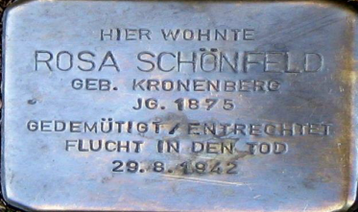
Rosa Schönfeld’s Stolperstein
Schiersteiner Strasse 31, Wiesbaden

Because Bernhard remained a bachelor and therefore had no direct heirs, he bequeathed the store to his nephew Werner, Ida and Ferdinand’s eldest son.

3.7 Brief biographies of Ferdinand Jelinowski and Ida Kronenberg

Ferdinand Jelinowski was born in Johannisburg (Pisz), East Prussia, the son of Isaak (Yitzak) Jelinowski and Bertha (Baile), née Gruenspahn. He had an older brother named Leiser Leopold, born in 1872, and he probably also had an older sister named Ida.

A family photo presumably shows Isaak with one of his children.

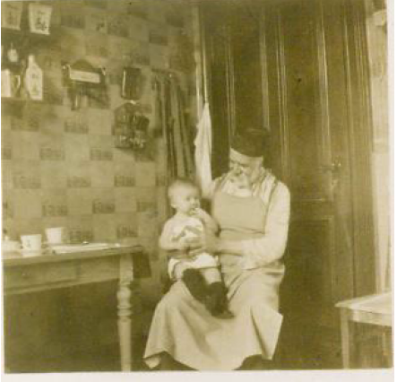

He is listed as a trader in the city’s taxation register for 1901-1902 (column 1, line 11)

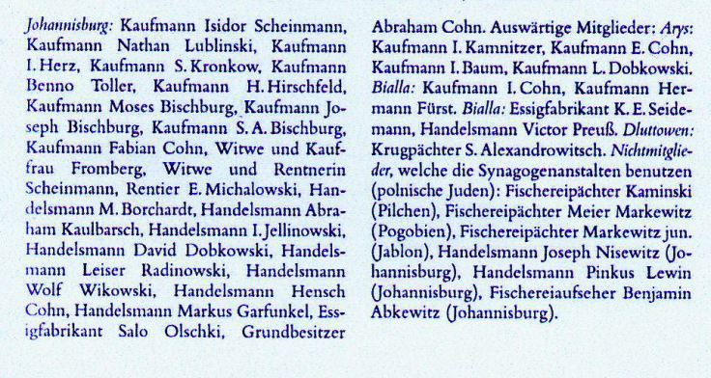

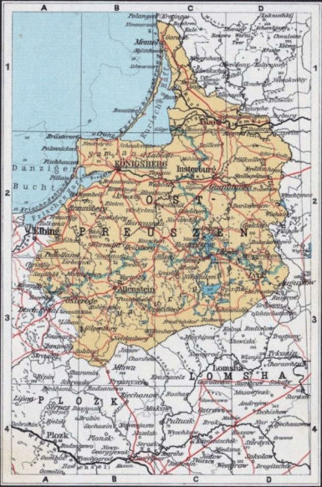
Map of East Prussia

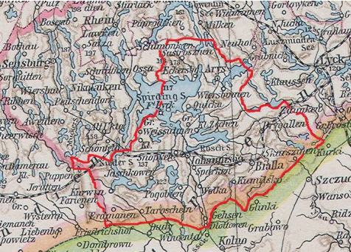
Cutout of East Prussia map showing Johannisburg

Johannisburg, a former district administrative center, is located in the Masurian borderlands and had developed under the protection of a castle belonging to the Teutonic Order. The city was the economic center of an agrarian region. Today the city is named Pisz, Poland (previously also Jansbork), and currently has about 20,000 inhabitants.

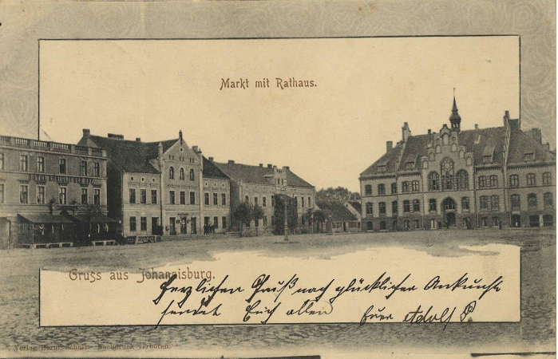

The first Jewish families presumably settled in Johannisburg in about 1810; by the 1830s-1840s, their numbers had swelled considerably. The synagogue community was founded in 1847 or 1854. The 1890 census indicates that Johannisburg had 3222 inhabitants, including 148 Jews.

As a result of an agrarian crisis in about 1900, large numbers of people left Johannisburg and the region around it, Jews among them. The Jews had played a major role in the city’s trade, and the primary occupation of the Polish Jews who had settled there and obtained residence rights was in the fisheries that had developed in the region’s lakes.

3.8 From East Prussia to the Ruhr Region

Leiser Leopold settled in Gelsenkirchen in 1895, where he soon opened a men’s clothing store located at Schalker Str. 29.

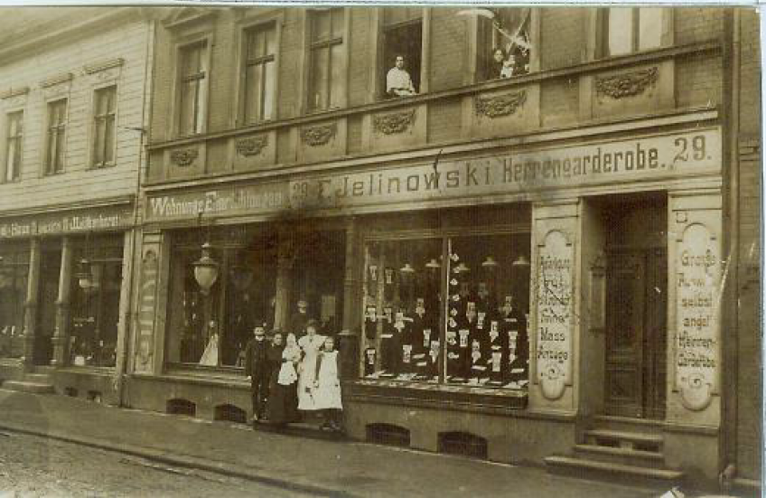

His sister Ida is registered as working with him in Gelsenkirchen in 1899, although she apparently returned to Johannisburg a few years later.

From 1894 to 1897 Ferdinand did an apprenticeship as a salesman with a manufacturing company in Riesenburg, East Prussia (now Prabuty, Poland)

Records indicate that in 1903 he was employed selling manufactured goods and hardware at the Fromm department store located at Kaiserstr. 54, in Herten.

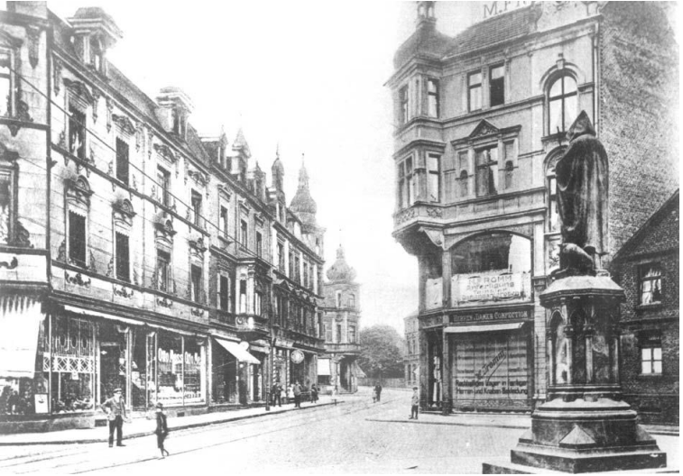
Fromm Department Store at the statue of St. Anthony (photo: Herten city archive)

In 1903 he is also registered as a “merchant’s clerk” or “commercial traveler” in his brother’s store.

3.9 The Jelinowski-Jelin Family

In 1904 Leopold married Clara Oppenheim in Rahden. Their daughters Edith and Ruth were born in Gelsenkirchen.

In 1907, Ferdinand married Ida Kronenberg, the daughter of Nachmann and Johanna, née Dalberg, in Geseke.

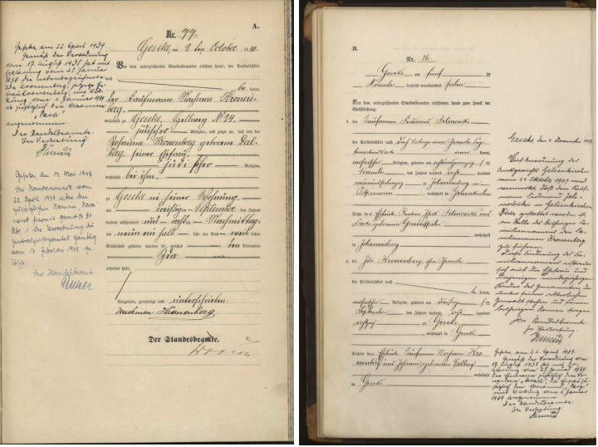

Ida‘s birth certificate Ferdinand and Ida‘s marriage certificate

When Ferdinand opened his own men’s clothing store at Schalker Str. 49, Leopold and his family moved to the nearby town of Herne, where in 1930 they changed their family name from Jelinowski to Jelin.

In 1942, their daughter Else was deported to Riga, and in July he and his wife Klara were deported, first to Theresienstadt, and then to Treblinka, where they were murdered. Their other five children were able to flee Germany in time. His sons Kurt, Roberto, and Fred Jellin were each interviewed for several hours by the United States Holocaust Memorial Museum.

Family tree of Leiser/Leopold Jelinowski/Jelin/Jellin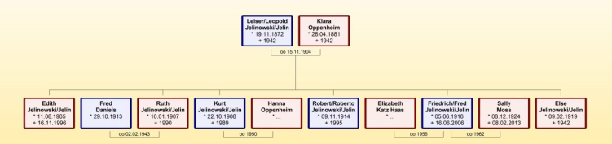

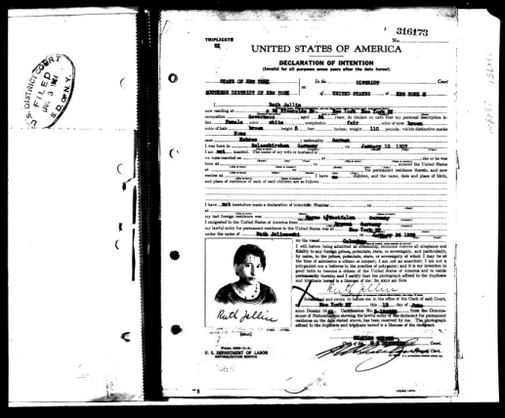
Ruth Jellin’s declaration of intention to immigrate, 1931

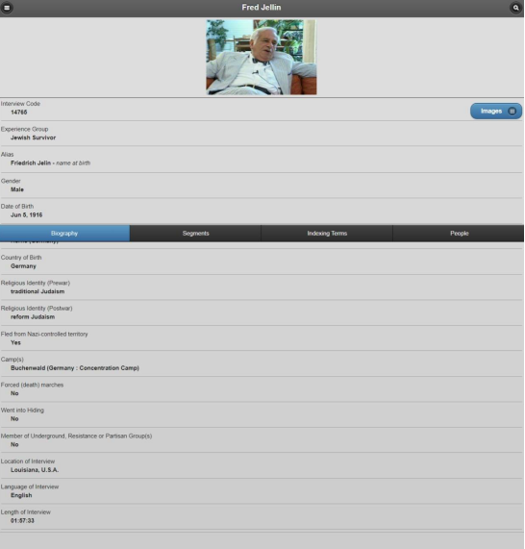
Fred Jellin’s USHMM interview code 14765

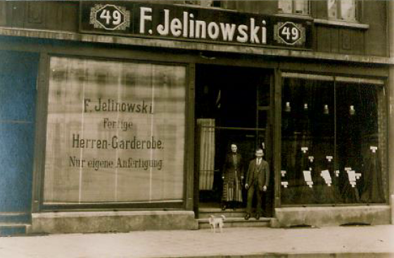

Ferdinand’s three sons Werner (1909, Norbert (1910), and Gerhard (1915) were born in Gelsenkirchen, where they attended the local schools.

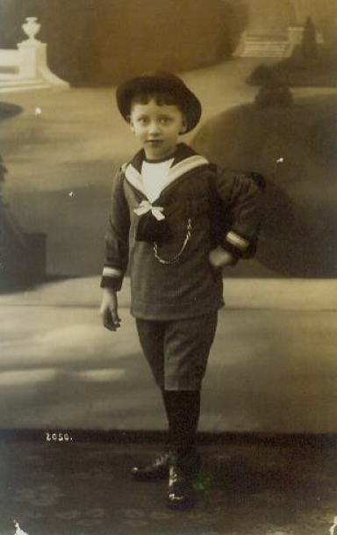
Werner Jelinowski on his first day of school, 1915

3.10 The First World War

Because both Ferdinand and his brother Leopold were drafted during the First World War, their wives had to take care of the children and businesses by themselves. During this time Ida wrote the following verse:
The Soldier's Wife
Dearest: Recently I thought of you
As the rain beat down throughout the night;
Bereft of sleep I could only rue.
Which of us bears the harder plight?
If I were with you, I'd not fear,
But the nights alone are dark and drear.
Yes, it's hard to be a man, I know,
But hard is, too, the road I go.
The other day, your boy let out:
"Will Daddy be coming home real soon?
Why is there war? Why does he fight?"
Questions in which innocents delight.
Dearest: How would you have answered him?
You are a soldier, but I stand with others:
An army of loving wives and mothers
All working toward a future bright
When we will live in peace and light,
If all will do their share.
Dearest: This is how I thought of you
As the rain beat down throughout the night.
Bereft of sleep; still I knew in my heart
That each of us shoulders their part.

Ferdinand was seriously injured in 1915:
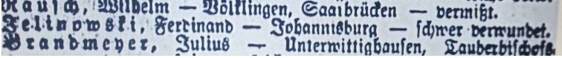
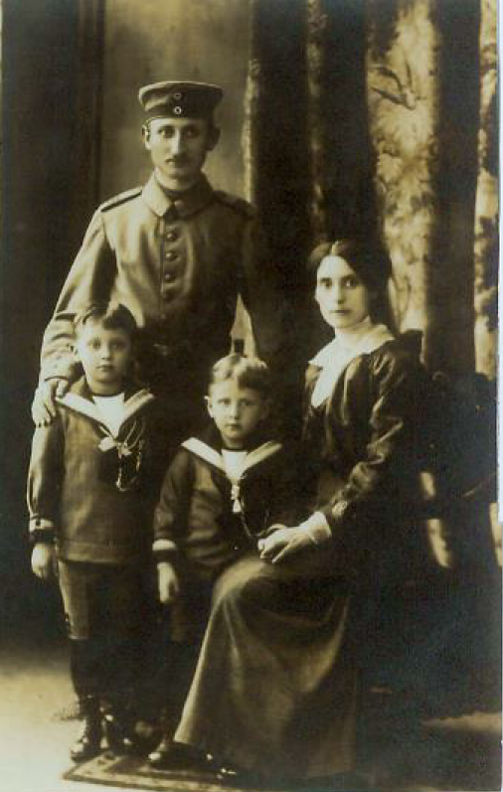
Ferdinand with Ida, Werner, and Norbert (about 1915)
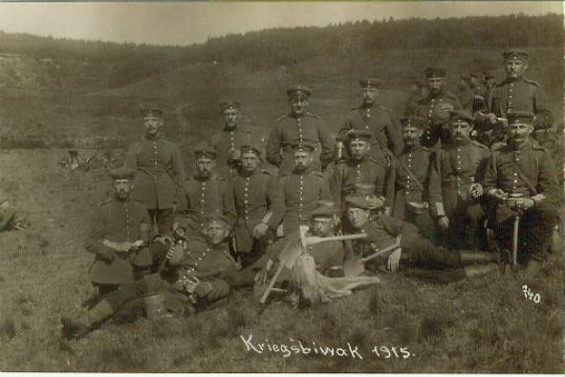
Ferdinand, rear row, second from the right
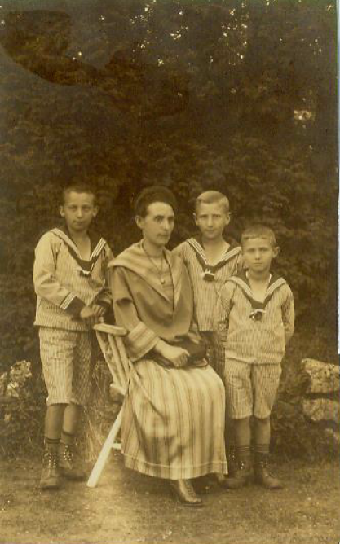
Werner, Ida, Norbert, and Gerhard
Ferdinand‘s son Norbert was active in the “Schild,” the sports group of the Reich Federation of Jewish Front-Line Soldiers. They also organized recreational activities such as camping.
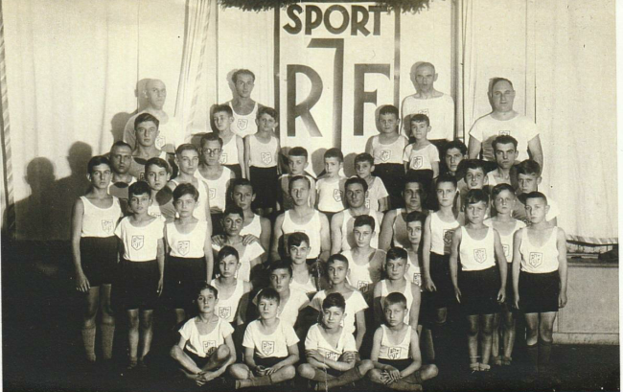
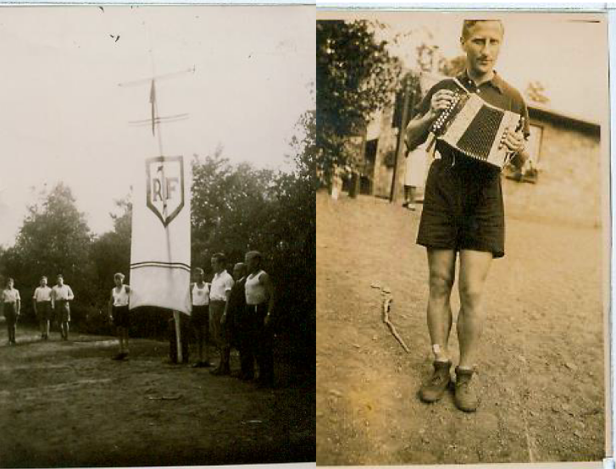
A Reich Federation event and Norbert playing the accordion
In 1929 Ferdinand Jelinowski adopted his wife’s family name Kronenberg, most probably in response to the increasing animosity in Germany toward Eastern European Jews.
From 1929 to 1932, their son Gerhard attended business school in Gelsenkirchen and completed his apprenticeship at Gebrüder Alsberg A.G., after which he was hired in the carpet and curtain departments at Westfalen Kaufhaus A.G. However, at the end of October 1933 he was let go because of the “poor economic situation.”
3.11 From Gelsenkirchen to Geseke
As a result, Gerhard relocated to Geseke in November, where his brother Werner had been living since the end of December 1931. As mentioned previously, Ida’s unmarried siblings Bernhard and Hedwig had already chosen their nephew Werner to take over the store on the Hellweg.
Norbert relocated to Geseke in September 1935.
Ferdinand and Ida lost their store in Gelsenkirchen, and followed their son Werner to Geseke in 1933.
3.12 Boycotts and Flight
Calls to boycott Jewish businesses and increasing repression throughout Germany made life difficult in Geseke as well. In 1935 Werner Kronenberg was forced to sell garden properties, and he was placed in “protective custody” that same year for opposing the boycott. The following is an article in the Geseker Zeitung from 1935:
“In protective custody
On Wednesday evening an excited group of people angrily gathered in the Hellweg in front of the Jewish Kronenberg store, protesting against the provocative behavior of the owner. The reason for the protest was as follows: In the Hellweg a large sign had been put up to educate our racial/national comrades. It read “The Jews are our misfortune.” In response, the Jew Kronenberg who lives nearby placed placards in his show windows that read “Only quality matters!” This conscious provocation against our racial thinking was the reason our Geseke racial/national comrades organized the protest. Speakers demanded removal of the placards. Because Kronenberg refused to comply with this demand, and because he and his fiancée, who was living with him, acted provocatively, the police took both of them into protective custody for their own safety.”
However, a report by the mayor to the political police shows that the boycott was not supported by large portions of the Geseke population.
The Mayor of Geseke
Report for July 1935
(“Report on the political situation”)
Geseke, July 22, 1935 StA Ms, Polit. Polizei III Reich, 350
“General mood
“The general mood in this reporting month is largely the result of the propaganda for and against the local Kronenberg store. I reference the special report that I have already submitted on this matter. Whereas those in the population who agree with the National Socialists were very angered at the arrogant nature of Kronenberg’s response, particularly lately, it has been determined that a not small percentage of the inhabitants are completely on the Jew’s side. What is characteristic is that this circumstance is evident in all classes of the population. In particular, it has become clear that even a proportion of local farmers have shown sympathy for Kronenberg.
“As previously reported, unknown persons had written anonymous letters to the majority of inhabitants who buy in Jewish stores, in which they were made aware of their traitorous actions. Various recipients of these letters have publicly stated that they will now make a point of buying from Jews. Kronenberg has apparently understood how to attract his customers. This sympathy may be the result of the extremely low prices that he advertises, but also because he now and again donates goods to needy families. Other Jewish businesses besides Kronenberg’s have also seen a very lively trade. This is particularly true for Schild’s feed store, which is frequented not only by Geseke farmers but also farmers from near and far. Kronenberg’s protective custody and that of his saleswoman caused considerable upset among those who sympathize with him, although this has abated considerably over the past few days. It has also been observed that his business has decreased considerably over the past few weeks. This decisive action by the responsible parties has been greeted by the National Socialists in the city.”

Werner Kronenberg married Ernestine Rahel Estlein from Kassel in 1936.
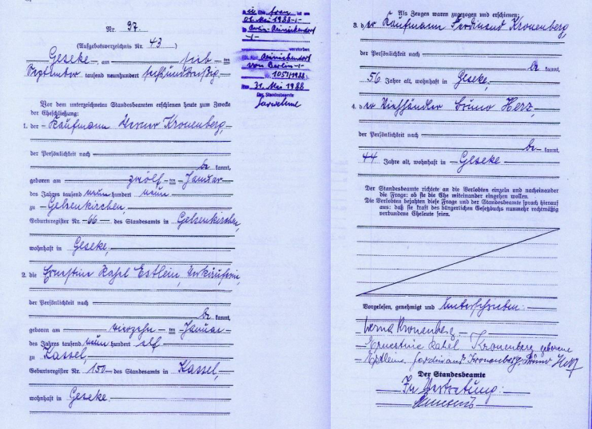
Marriage certificate of Werner and Ernestine, dated September 7, 1936
Werner’s mother-in-law Clara Estlein, née Lipschütz, originally from Bremen, and his sister-in-law Mirjam Estlein were deported from Berlin on August 15, 1942 to the concentration camp in Riga, where they were murdered.

“Estlein, Clara, née Lipschütz, born September 1885 in Bremen, residing in Ludwigshafen am Rhein and in Berlin (Prenzlauer Berg)
DEPORTATION from Berlin August 15, 1942
DATE OF DEATH August 18, 1942
PLACE OF DEATH Riga

Estlein, Mirjam, born July 27, 1929 in Ludwigshafen am Rhein, residing in Ludwigshafen am Rhein
DEPORTATION from Berlin August 15, 1942
DATE OF DEATH August 18, 1942
PLACE OF DEATH Riga”

Werner’s brothers Norbert and Gerhard fled Germany to South Africa by way of Holland and England in 1936. On their flight, they stayed in Amsterdam with Julius and Bella Dalberg, relatives of their grandmother, Johanna. Unfortunately, Julius and Bella Dalberg were unable to escape. Their fate is documented in detail at “Stones for Sobibor.”

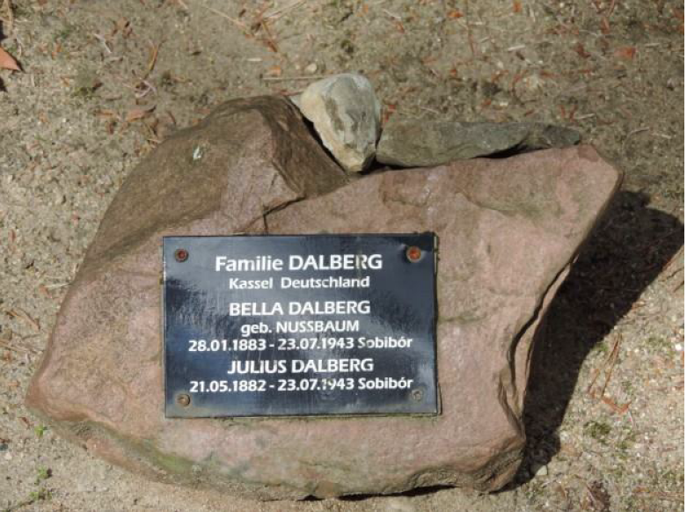

Julius Dalberg
born on May 21, 1882
in Essentho, Hessen, Germany
married
Bella Dalberg, née Nuszbaum
born on January 28, 1883
Bad Hersfeld, Hessen, Germany
Julius Dalberg and his wife Bella Dalberg had lived in the
Hohenzollernstrasse, in Kassel, since 1911.

Julius Dalberg had studied law and had a law practice. He was the community elder of the Jewish community and edited the Jüdische Wochenzeitung für Kassel, Hessen und Waldeck [Jewish Weekly for Kassel, Hessen and Waldeck]. He published numerous articles about the history of the Jews in Kassel. Dalberg was a knowledgeable collector of antique art and antiquarian books. Professionally he had frequent contact with the Nazi lawyer Oswald Freisler, brother of the notorious Judge President of the People's Court in Berlin, Roland Freisler. On March 24, 1933 he was seriously beaten up by the SA. This incident is recorded in the Brown Book of the Hitler Terror and the Burning of the Reichstag:

“On the same occasion another lawyer, Herr Dalberg, was most brutally treated in the same way as Plaut, and at the same place. It should be noted that sometime previously he had had a conflict in court with a lawyer [Freisler] who is now in an official position; this dispute was brought up against him while he was being mishandled. There can be no doubt therefore that the tortures inflicted on Dalberg were due to direct instructions from this high Prussian official, who had previously been in command of the Cassel National Socialists. Dalberg was so badly injured that for some days the doctors were afraid that one leg would have to be amputated, but fortunately it was found possible to save it. Dalberg is still severely affected by the results of his ill-treatment.”

On September 1, 1933 he was arrested and sent to the Breitenau concentration camp. Two weeks later he was released and fled to Amsterdam with his wife Bella. There he founded a Jewish-scientific antiquarian bookshop " Pampiere Wereld". After the invasion of Holland by the German Wehrmacht, in May 1940, the antiquarian bookshop was closed. They were registered as living in Amsterdam between January 8, 1934 - June 1, 1943 at the address, Noorder Amstellaan 31 A III in Amsterdam.
Julius and Bella Dalberg were taken to the Westerbork police transit camp on June 1. Together they were deported with the 19th transport that left the Westerbork camp for the German extermination camp Sobibor in Poland on July 20, 1943. There were another 2007 people in this transport, none of whom survived the war. It is assumed that Julius and Bella Dalberg, were murdered immediately after their arrival at the Sobibor extermination camp on July 23, 1943.

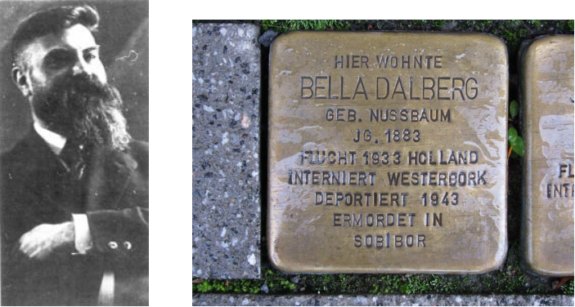
Julius Dalberg Stolperstein at Friedrich-Ebert-Str. 3
Formerly Hohenzollernstr. 5, Kassel

Norbert and Gerhard were in frequent correspondence with their parents in Geseke, and tried to support them and help them emigrate, as the following letter excerpts from Norbert make clear:

Circular letter no. 13
Springs, December 30, 1937

TO ALL MY LOVED ONES!

First of all the most important thing: Gerd, who always spends his weekly 1½ free days with me, brought me an application form from the Netherlands Bank for South Africa so that as of January 1938 I can send you £5 each month. For the time being I have entered the sum of RM 100, with which I am sure you will be able to make do in Geseke. However, if you should have any other requirements, write to me IMMEDIATELY.

Of the £24 that I earn, I only spend 10-12 per month anyway, and I am only too happy if I can be of help to you. You should have absolutely no difficulties with the money; the postman will bring it to your house. One might possibly demand a certificate of need from you (which of course wouldn’t be difficult for you!!), But as the other boys who are sending money home tell me, it has never been demanded before. According to the exchange rate for REGISTER MARKS, you will get 20-23 ACTUAL REICH MARKS per pound. (I think that the state will retain 1%.)

But please do me the favor and USE THE MONEY and DON’T SET IT ASIDE IN SOME WAY!!! I DO NOT WANT YOU, DEAR FATHER, TO RIDE AROUND ON YOUR BICYCLE DURING THE WINTER MONTHS. Have I made myself understood??!! You will stay at home with your rear end by the warm stove and listen to radio!! (Apropos radio, I had asked Werner to give you a network connection device from Telefunken or Schaub in my name for your birthday (and belatedly for mother’s). I was going to pay him back for it, but since he hasn’t done it, buy one yourself, and I recommend a mid-range one of the “5 from Telefunken,” SABA, or Schaub, in any case with excellent European reception in the price range of about RM 250. BUT PLEASE DO, so that when Mother sits at home alone she has some sort of diversion so she doesn’t keep imagining the most horrible mine disasters at the Spring Mine (you see, I know our Ma!)

The first application for transfer will probably take 4-5 weeks; I will inquire tomorrow whether it can’t be done by telegram. Later it will arrive regularly by boat postage. But for God’s sake don’t set the money aside so that some other person might grab it (you understand what I’m saying). Use it. If you have a passport or can get one, go and visit Uncle Dalberg in Amsterdam or in the spring go to Bad Driburg or Pyrmont. After all, the two of you want to come here to South Africa – HOPEFULLY IN THE COMING YEAR!!! – But then both of you have to be healthy because we have no use for sick people down here! How is your eye, dear Ma? We are always tremendously happy with your letters, but the small script on the thin paper must be particularly difficult for you. Please leave the writing to Father and limit yourself to dictating to your private secretary whose energetic handwriting is easier for us to decipher. I will probably send the money in the form of Ha’avara marks (comes to the same for you), which is completely legal, which is of benefit to Jewish émigrés because it offers possibilities for transferring hard currencies. We will discuss how and when you will follow us down here later. In order not to awaken premature hopes, I want to wait for the results of the July election here before I initiate anything, because if the leader of the Nationalists, Dr. D. F. Malan, should win a decisive place in government this may cause difficulties. If not, the limitations on immigration decreed in February 1937 will undoubtedly be eased. I will keep you up-to-date on these developments, and in any case you will find out about it just as early in the C-V Newspaper (which I ask you to keep subscribing to). Just today I received another 3 editions, which pleased me greatly. Thank you!!)

Gerhard eventually moved from South Africa to Toronto, Canada, to be near his son Wulf. We continued to be in correspondence with him and his wife Bertha until their deaths.

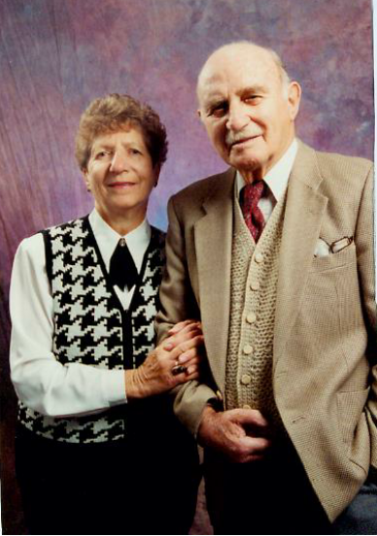
Bertha and Gerhard Kronenberg, 1996

In 1937, N. Kronenberg on the Hellweg was Aryanized in a forced sale.

Celebrating the 75th anniversary of their family’s acquisition of N. Kronenberg, the Rusche company had the following to say:

"In 1937 Konrad Rusche and his wife Änne lay the cornerstone for something that Franz-Josef and Monika Rusche [parents of the current owner] would expand into a success story between tradition and future."

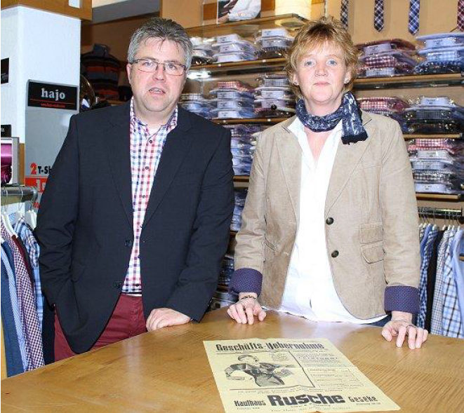
The Rusches with 1937 leaflet announcing “Business Takeover”

In 1937 Werner and his wife Erna intended to settle in Colombia, emigrating by way of Havana. Eventually they made their way to the United States. During the Second World War, Werner was an OSS agent stationed in London. He is said to have parachuted behind enemy lines to bring out US and RAF pilots who had been shot down. After the war, Werner founded Ruhr Industries, in Philadelphia, which imported heavy German machinery.

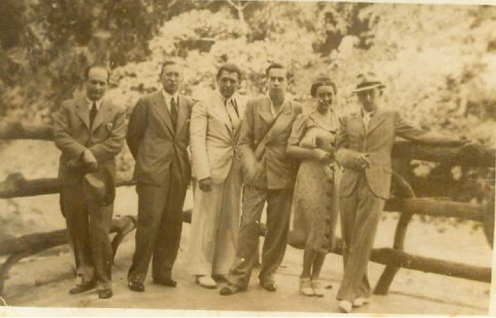
Erna and Werner Kronenberg in Havana, 1938

Their son Kenneth was born on December 25, 1946. He first learned German when he spent part of a year in Geseke, in 1951, when his parents sought reparations. We have been in contact with him since 1992, and he has visited Geseke several times since then.

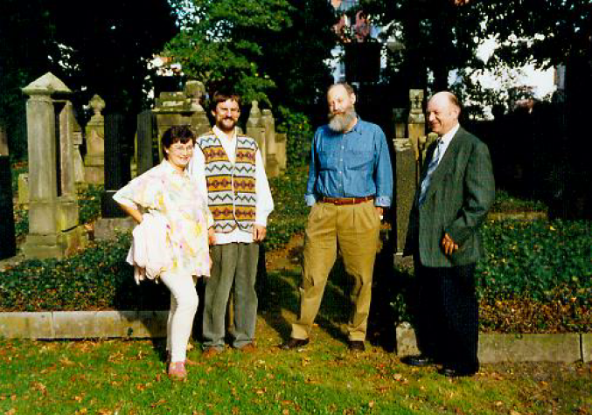
At the Jewish cemetery in Geseke, 1995
Nerina and Reihard Marx, Kenneth Kronenberg, and Friedhelm Budde

3.13 “Reichskristallnacht” and “Protective Custody”

Ferdinand and Ida Kronenberg initially rented in Geseke at Völmeder Strasse 7; he is listed on the tax rolls for 1935 at that address. After 1938, they moved to Orth-ab-Hagen Strasse 20.

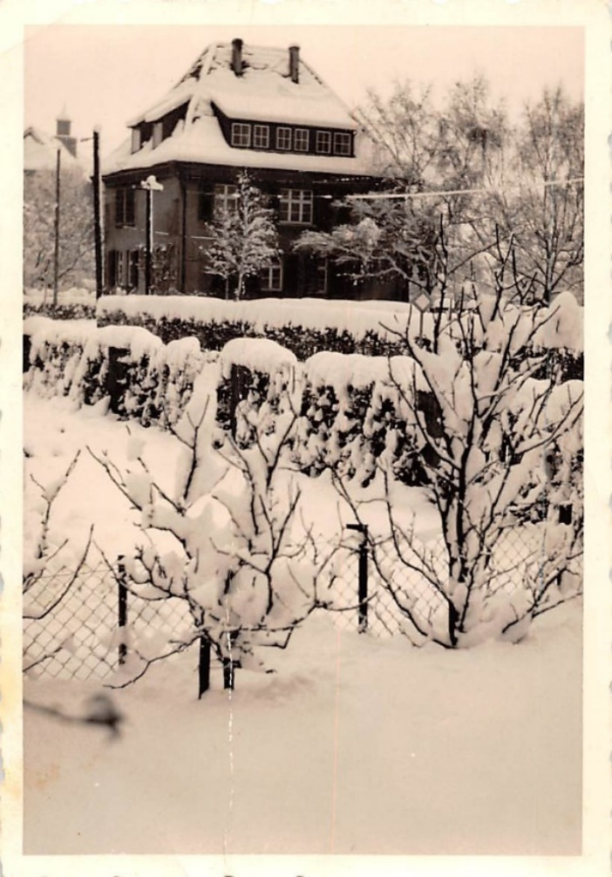
Völmeder Strasse 7, 1951 (photo: probably Erna Kronenberg)

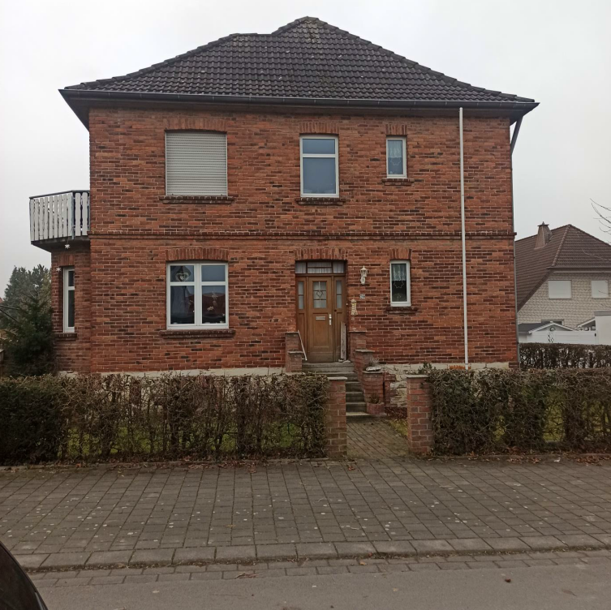
Orth-ab-Hagen Strasse 20, 2020

The so-called Reichskristallnacht, an outbreak of violence against Jews organized by the National Socialists throughout Germany, was felt in Geseke as well. The then mayor reported on the violence to the Gestapo headquarters in Dortmund.

The Mayor
in His Police Capacity
Sect. IVb.
Geseke, November 10, 1938
1) To the district office of the Geheime Staatspolizei, Dortmund.
With regard to the events reported by telephone through my subordinate this morning at about 6:00, I make the following report:
Last night at about 3:30 there was a tumult in front of the local Jew houses, in particular buildings owned by the Jews Artur Steinberg and Max Abel. The former owns a larger building out of which he once operated a hardware store. For some time, however, it has been rented to an Aryan racial/national comrade. While the store is on the ground floor and inventory is stored in the attic, Jew Steinberg has his apartment in the 1st floor. All of the windows there were smashed in. The demonstrators demanded loudly that Jew Steinberg should come down. When this did not happen and the front door was not opened, they used a ladder to climb through the window and forced the Jew to go downstairs with them. Apparently damage was limited to the windows of the floor occupied by Steinberg, while the other parts of the building that are rented were untouched.
In the meantime, several demonstrators moved on to the building owned by Jew Abel, the cattle dealer [lit. cattle-Jew Abel], who has rented to several Aryan racial/national comrades, while he himself lives in the 1st floor. The people living downstairs opened the door for them, and they thus gained access to Abel's apartment. They demanded that Abel get up and come with them; they then smashed all the windows in his private apartment. In the meantime, the local SS commander, who had been informed of the events by someone per telephone, arrived on the scene with several SS men; in order to prevent further such actions, he placed the two Jews under his protection. The demonstrators then wanted to break into the Jewish synagogue, probably in order to continue destroying. For several weeks, unrestricted access to this synagogue has been granted to the local police and town administration by a written declaration signed by the local Jewish representatives of the synagogue. Because of this, the SS commander was able to prevent damage to the synagogue. He had both Jews brought into the synagogue and placed under SS guard there.
In addition to the demolition of the homes of Jews and of the synagogue, he reported the following about the Kronenberg family:

Meanwhile, Jews Herz and Kronenberg, who are renters in Aryan houses, were also forced out of bed and brought to the synagogue.

There was no damage to apartments rented by Jews from Aryan racial/national comrades. The SS then brought the 4 Jews to the police administration where they were temporarily placed in protective custody for their own safety as it was feared that there might be further actions taken against them. On orders from the responsible judge on duty there and in order to prevent further attacks should the Jews be set free, they remain in protective custody for the time being.

According to eyewitness accounts by Geseke citizens, the police abused the Jews by forcing them to do “gymnastic exercises” and “foot-washing” in the pond.

Ferdinand was then taken to the camp at Sachsenhausen. In a letter to her children in South Africa, dated December 6, 1938, Ida wrote:

“Now, thank God, Father is here and, except for a cold, is healthy. I had written to Werner and received the following telegram: “Affidavits being applied for, send next day per email, necessary papers for America acquired. Baggish.” I just returned from the city office with Father, and we must [leave] within 14 days or 3 weeks if we have not yet emigrated to you but can present the documents. Dear children, find out what is to be done. Otherwise, we must go to America first if it happens more quickly, and then come to you later. Or whether it is possible to remain in Holland for that long. I am unable to undertake anything from here. Perhaps you will have more luck. Things are very hard for us to buy, I’m constantly trying. Small items are gone. I hope that everyone is healthy and will help us. Please quickly so that we are not again alone. Can’t your local aid association do anything for us? Passage or upkeep in Holland? Warm greeting and kiss from your Mother”

3.14 Denial of Emigration

These events destroyed any illusion that decorated war veterans and their families might be spared. That same day, Ferdinand was forced to sign the following declaration:

Geseke, December 6, 1938

The Jew Ferdinand Kronenberg, born on November 28, 1879 in Johannesburg in East Prussia and living in Geseke, Orth ab Hagenstr. 20, has been summoned and declares:

I have been notified that I am to actively pursue emigration for myself as well as my family, wife, and children. Emigration is to occur within 14 days, at the most 3 weeks from the time of this notification. At the very least, by the time of this deadline, I must be able to show documents that demonstrate that my attempts to emigrate have taken tangible forms.

Should I be unable to produce such documents, and should I intentionally delay my emigration and that of my family, I may count on renewed imprisonment and/or other police measures.

v. g. u.

(signed) Ferdinand Kronenberg

In the end, increasing bureaucratic red tape and attempts to find a safe haven outside Germany failed:

In January 1940, the Reich Association of Jews in Germany sent him the following notice:

The countries cited by you only permit transit stays because work and income opportunities are completely forbidden…. The sum of $500 must be shown upon entry, along with $50 to cover the cost of making out the residence permit. The residence permit may be renewed after 6 months, if the above-mentioned sums are produced or can be paid. You could be permitted to settle there as a farmer, but that would require $5000.

The American consulate in Stuttgart responded to Ferdinand’s immigration application as follows:

Given the large number of applicants for immigration visas to the United States from persons who have a lower waiting number than yours, it will not be possible to consider your application in the foreseeable future.

It is therefore not feasible to determine at the present time whether the guarantees [you have submitted] will suffice, especially because in general guarantees become invalid after a year, and with them also the documents associated with them. You will be informed at the proper time when your waiting number comes up, and you will then have to present documents bearing a more recent date regarding guarantees of your livelihood in the United States.

3.15 Help from Geseke Residents

A letter from the then mayor of Geseke Reckhard makes clear that there were members of the Geseke community who tried to help the Kronenbergs, despite the risks involved:

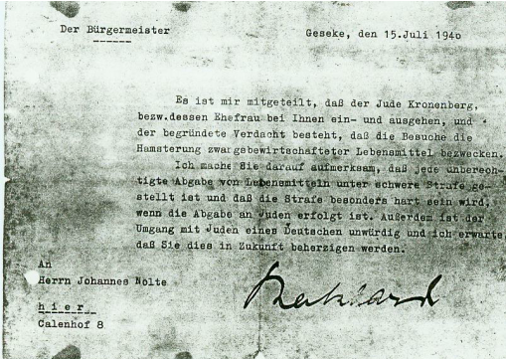

[Translation]:
The Mayor
Geseke,
July 15, 1940

I have been informed that the Jew Kronenberg and/or his wife have been going in and out of your place. There is a well- founded suspicion that the visits are for the purpose of hoarding rationed foodstuffs.

I draw your attention to the fact that all unauthorized distribution of foodstuffs carries severe penalties and that the penalty will be particularly harsh if distribution is made to Jews. Furthermore, consorting with Jews is unworthy of a German, and I expect that you will bear this in mind in the future.

To:
Herrn Johannes Nolte

Ferdinand Kronenberg was forced to clean the streets of Geseke from May 23, 1940 to July 18, 1942.

Once the Kronenbergs’ financial reserves were depleted, they lived in complete poverty. This is very clearly described by Frau Elizabeth Rohde, née Eulentrop in the following report titled “The Last Jews in Geseke”:

The following is an account of my experiences during the years of National Socialism when many people, particularly Jews, were despised and destroyed. They were allowed to starve and were exterminated in the most merciless fashion. As a young girl I was powerfully affected by this, and I think it is especially important to talk and write about these horrible deeds today and not keep them secret.

As a young girl I became acquainted with Jewish people who often visited my parents' home. My parents raised poultry, and since Jews may not eat pork on account of their religious beliefs, they often bought poultry from us. In this way I had early contact with Herr and Frau Kronenberg.

Ferdinand and Ida Kronenberg had once run a thriving business in Geseke. After Hitler's seizure of power, they gradually had to sell all of their possessions just to be able to live. They became poorer and poorer until there was hardly enough for their daily bread. Herr Kronenberg was made to clean out the sewers, certainly not fit work for a man of his age. My mother told them that they could come get what they needed to live. So Frau Kronenberg would come and get vegetables, eggs, butter, and bread from my parents.

One day Frau Kronenberg came again and picked up a few things. My uncle Wilhelm, who was disabled, was alone in the house with us children while my parents were working out in the field. I went and got lettuce and carrots from the garden and packed together everything that they might need. Many people went hungry during those years, including our soldiers who were fighting in the war. Wasn't it also our duty to help the Jews? When Frau Kronenberg came she never asked for much and was grateful for whatever she received.

After I had picked the carrots, I cut off the greens and then packed everything up. Frau Kronenberg had just left when our neighbor, who was a hard-core Nazi, came over and said to my uncle in a very angry voice: "Wilhelm, what did that old Jew woman get here again?" My uncle said to him, "Heinrich, she just got a few carrots. Look, you can see the cut greens on the ground!" Our neighbor, however, claimed that she had gotten much more, and then he threatened, "If I ever see that old Jew woman here again, I'll make sure you end up where you won't like it." At this moment, my little brother came out of the kitchen, where he had been doing his homework. He had heard everything that this man had ranted. Quietly and with all the innocence of childhood he said, "Thou shalt love thy neighbor as thyself." Our neighbor left the house in a blind rage. However, after a short time he returned and asserted that my brother could not possibly have said that on his own but had been put up to it. He was angered even further when my uncle apologized and asked him to please let the matter drop.

That night we talked about how we could best continue to help the Kronenbergs. We came to the conclusion that we would have to bring food to them in such a way that our neighbor would not find out. My mother then said to me: "Listen, you still have young legs. You bring the old people what they need." Together we figured out what route I should take so there would be no suspicion, because the Kronenbergs lived on the other end of town.

That is how it happened that I brought the old people what they needed. We told them that everything would continue as before. I would start out at night when it was dark. It was a long distance, so I would run part of the way. When I arrived at the apartment and rang the bell, Frau Kronenberg would open the door and look out carefully to see who it might be. When she recognized me, she would quickly take me by the hand and lock the door behind us. Quietly we would tiptoe up the stairs because she didn't want to disturb the owner, who was still willing to rent them rooms. She kept saying, "We are Jews and don't want to burden anybody with it."

I went this route often. Because I was still young, I hardly comprehended the poverty. The Kronenbergs had almost no furniture left in their apartment: a table, two stools, a cabinet, an oven. Two empty orange crates stood upright against the wall topped by an unfinished board. That was where we often sat. One day they told me about their sons who had emigrated a while ago and lived in the United States. They said that when their sons returned to Geseke, I should give them their greetings and tell them how their parents had lived in their old age.

And so we often sat on that board which served as a bench. One evening the poor woman stood up, went to the cabinet, and took out a cup. The cup was cracked and was missing the handle. She took a medallion from this cup and said, "I want to give this to you as a memento. We don't have very much left." Then she asked her husband, "Don't you have a little something as well?" Herr Kronenberg thought it over and said, "If they come to get us one of these days and don't find anything here, they'll beat us on the spot." Frau Kronenberg looked sad and replied, "What is our life still worth?" He then came to a decision and removed a compass from his watch chain. Looking at me he said firmly, "Keep this to remember us Jews. If you come here one of these days and nobody answers the door, you will know that they have taken us away."

I kept going to the Kronenbergs' until one day the door remained locked. Lost in thought I walked back home with my bag of food. I never saw them again. Only the medallion and the compass remain, a constant reminder.

The small round object next to Ken Kronenberg’s left-hand in the photograph below is Ferdinand’s pocket watch. It was reunited temporarily with the medallion and compass in Frau Rohde’s possession. These three objects are now being donated to the Heimat Museum in Geseke.

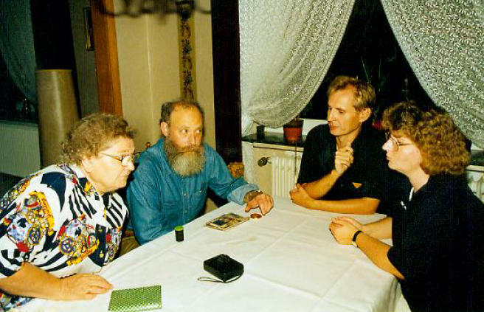

Kenneth Kronenberg in conversation with Frau Rohde and her children, 1995

3.16 Deportations and Holocaust

Ferdinand and Ida were deported from Dortmund to Theresienstadt on July 29, 1942, Transport X/1 Train Da 72, along with Ferdinand’s brother Leopold and his wife Klara.

From there they were transported to Auschwitz on May 15, 1944, where they were murdered.

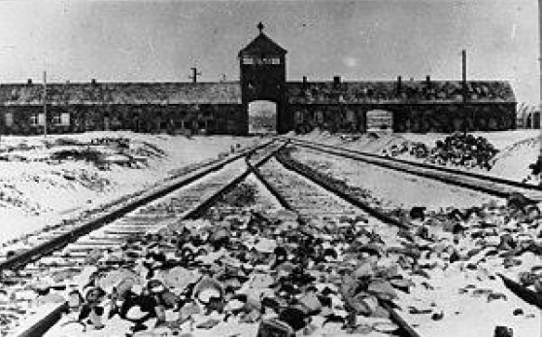
The entrance to Auschwitz-Birkenau
Central database of names of Holocaust victims

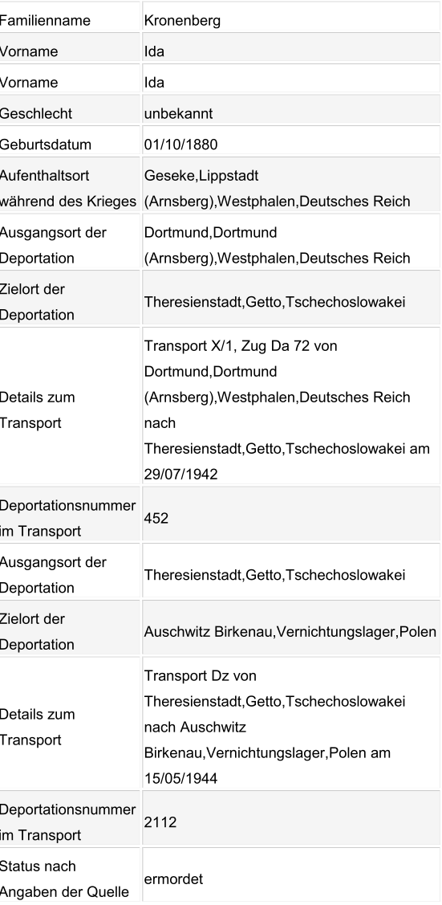
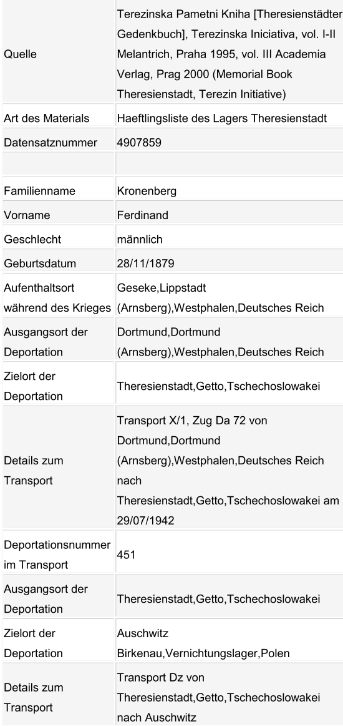
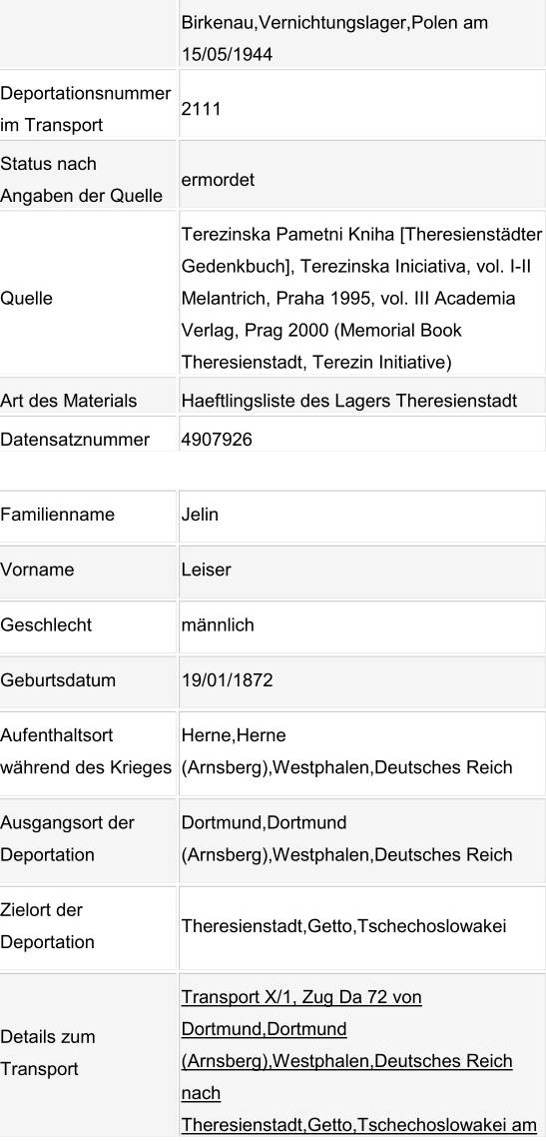
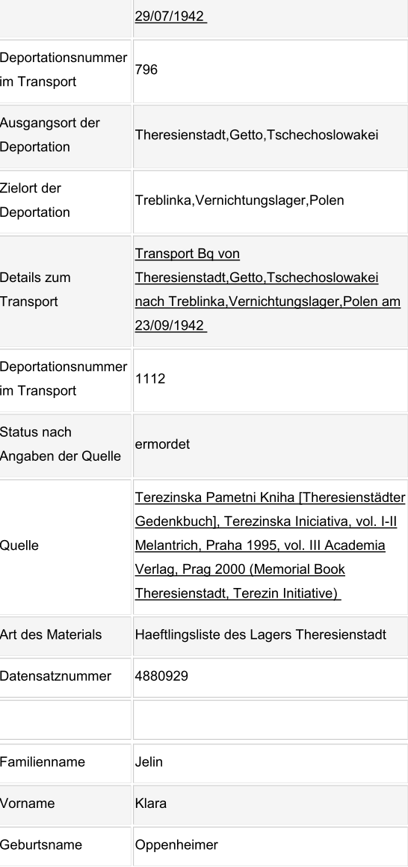
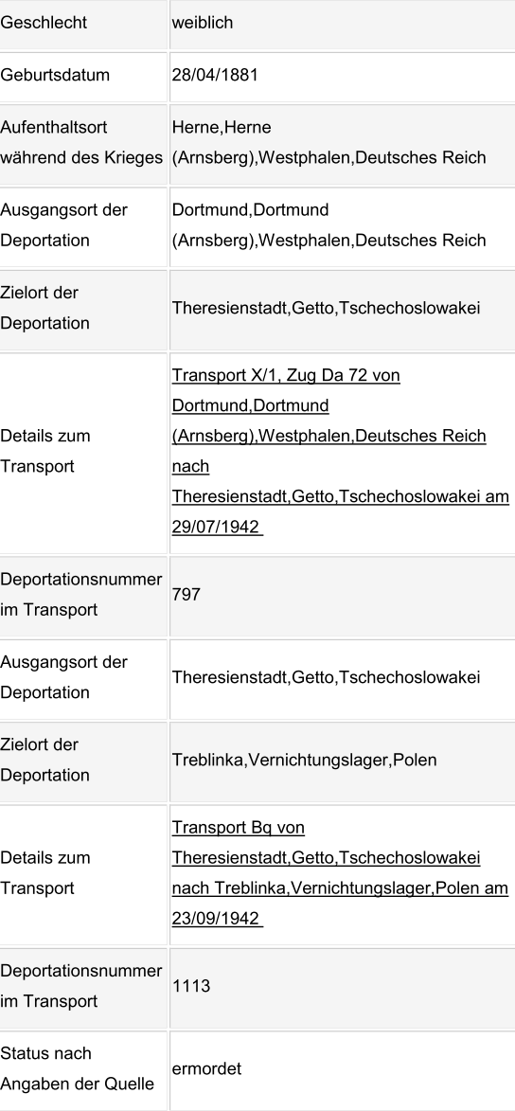
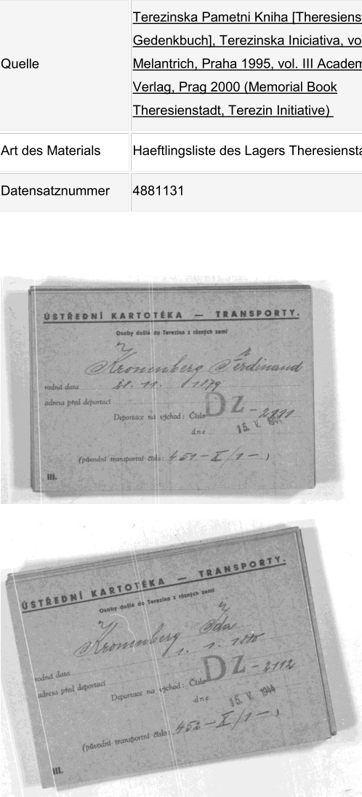
Transport cards, May 15, 1944

Gerhard Kronenberg made out the following Pages of Testimony at Yad Vashem in memory of his parents Ferdinand and Ida:

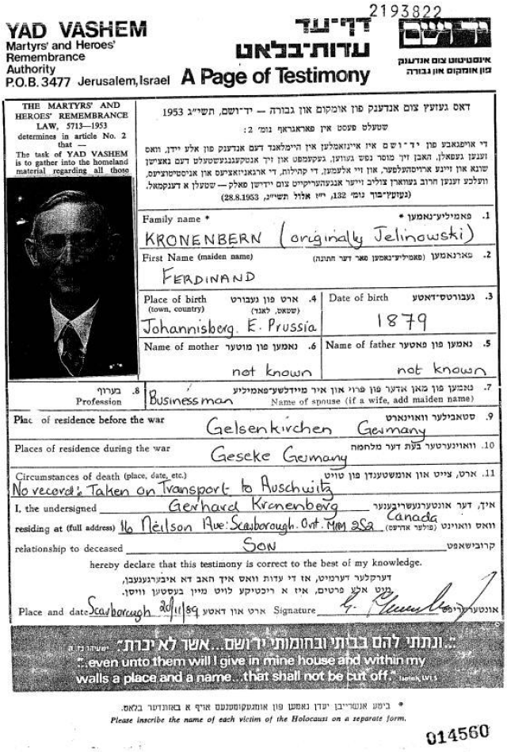

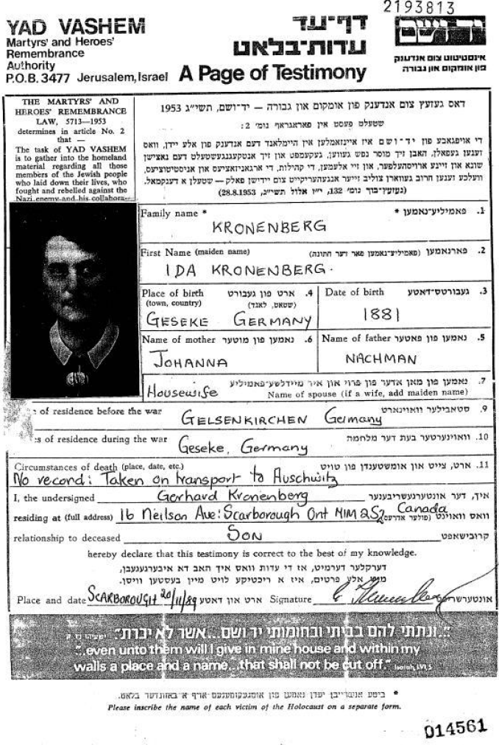

The following is a list of all members of the Kronenberg family known to have been murdered during the Holocaust:

Ida Kronenberg

Ferdinand Kronenberg, né Jelinowski

Hedwig Kronenberg

Rosa Schönfeld, née Kronenberg

Leopold Kronenberg

Elise Kronenberg, née Wittgenstein

Cäcilie Michel, née Kronenberg

Bertha Wittgenstein, née Kronenberg

Bertha Nussbaum, née Kronenberg

Johanna Mosberg, née Kronenberg

Laura Sander, née Kronenberg

Paula Ruth Kronenberg

Leopold Jelinowski/Jelin

Klara Jelinowski/Jelin, née Oppenheim

Else Jelinowski/Jelin

Clara Estlein, née Lipschütz

Mirjam Estlein

4. Notes

Cf. Exhibition „Jüdische Familien in Geseke“, Hellwegmuseum 1992.
In W. Bramann, Emil Kronenberg-Solinger Arzt u. Schriftsteller, Solingen 2002.
„… und laut zu sagen: Nein.“, Exhibition at the Max-Leven-Zentrum Solingen 2020.
Stolpersteine Solingen, January 2019. See also https://nein.max-leven-zentrum.de/dr-emil-kronenberg/.
In W. Bramann, Emil Kronenberg-Solinger Arzt u. Schriftsteller, Solingen 2002.
In Arolsen Archives, 5007114-Emil Kronenberg.
Cf. http://zbf.solingen.freimaurerei.de/geschichte.htm.
Cf. Viersen Virtual Memorial 1933-45.
In W. Bramann, Emil Kronenberg-Solinger Arzt u. Schriftsteller, Solingen 2002.
In Gudrun Mitschke-Buchholz, Gedenkbuch für die Opfer der nationalsozialistischen Gewaltherrschaft in Detmold, Detmold 2022.
In M. Kronenberg, Geschichte des deutschen Idealismus, Book description at: https://www.buecher.de/shop/buecher/geschichte-des-deutschen-idealismus/kronenberg-m-/products_products/detail/prod_id/58135427/.
Compiled biography by Frau Hervitz and Herr Spur.
See https://sova.si.edu/record/NMAH.AC.0813
Cf. StAG, B. X. 56 Bd. 2 „Vergleitung und Geleit der Juden.“
In hanshesse.wordpress.com „Das Kronenberg-Journal.“
„…es geschah am hellichten Tag!“, hrsg. LpB 2005.
Cf. Archives départementales des Pyrénées-Atlantiques, 1 M 182.
Arolsen Archives, Emil Kronenberg, Signature: 03020102 oS.
In Arbeitskreis Jüdische Familien in Geseke, Juden in Geseke. „Beiträge zur Geschichte der Stadt Geseke,“ vol. 10, 1997.
Ibid.
Ibid.
Ibid.
See www.holocaust.cz/de/opferdatenbank/opfer/19788-hedwig-kronenberg.
Cf. Klaus Flick, Judenhäuser in Wiesbaden 1939-1942.
Cf. Andreas Kossert, „Aus der Geschichte der jüdischen Gemeinde zu Johannisburg/Ostpreußen,“ in: Brocke, Michael et al., Zur Geschichte und Kultur der Juden in Ost- und Westpreußen, Hildesheim 2000.
In Arbeitskreis Jüdische Familien in Geseke, Juden in Geseke. „Beiträge zur Geschichte der Stadt Geseke,“ vol. 10, 1997.
Cf. StA Ms, Polit. Polizei III. Reich, 350.
In Gedenkbuch Opfer der Verfolgung der Juden unter der nationalsozialistischen Gewaltherrschaft in Deutschland 1933 – 1945, Bundesarchiv Koblenz.
https://sobibor.de/de/?s=Bella+Dalberg
World Committee for the Victims of German Fascism (1933). Brown Book of the Hitler Terror and the Burning of the Reichstag. New York: Knopf, p. 234; read or download at https://catalog.hathitrust.org/Record/000462626
http://www.geseke-news.de/?p=7891.
In Arbeitskreis Jüdische Familien in Geseke, Juden in Geseke. „Beiträge zur Geschichte der Stadt Geseke,“ vol. 10, 1997.
Ibid.
Ibid.
Ibid.
Ibid.
Ibid.
Arolsen Archives, 5007116-Ferdinand Kronenberg and 5007114-Ida Kronenberg

